NECO Alliance

Rebate Processing

System

Chapter Administrator Processing

http://www.rebates.necoalliance.com/Login.php

Personal Systems Technology
www.PersonalSystems.biz
914-874-5184
Revision History

May 16, 2012
- Rebate Spend Analysis report – RebateSpendAnalysis3
March 27, 2012
- Chapter Serial Number processing – ChapterSerial1
- Campaign lookup by Sponsor/Manufacturer – CampaignSelect10
February 8, 2012
- NECO Merchandising Portal added [only available for authorized personnel]
January 13, 2011
- Manage member driving mileage to the Meadowlands for Spring Shows – MemberMaint1,2,3
December 13, 2010
- Model Search added – ModelSearch3,4
December 3, 2009
- Campaign Discussion added – CampaignDiscuss1,2,3
October 8, 2009
- Model report by manufacturer for a specific time period – ChapModelReport1,3
June 29. 2009
- eMail, full address spreadsheet processing – CustomerList1,2
May 11, 2009
- Category by Dealer report added to Campaign Select
April 27, 2009
- Download Model information in to a spreadsheet – see ModelReport2
September 25, 2008
- Provide rebate version history
  - Show version time stamp on rebate form
  - Show history of campaign changes – Campaign History [CampaignHistory1]
March 8, 2008
- Display dates in mm-dd-yyyy order
March 5, 2008
- Campaigns can be listed in Oldest First or Most Recent First order
- Menu, CampaignSelect3, CampaignSelect3c - updated
January 25, 2008
- Campaign Member List processing added
  - New Membership series – Campaign Lists
  - Update to Campaign Select [CampaignSelect3]
January 18, 2008
- The Manufacturer Summary [ReportActivity6] is updated to include activity by campaign.
January 17, 2008
- Email Maintenance updated to include Member Email [DealerEmailList1]
January 14, 2008
- Campaign Select split to CampaignSelect3 for Preview and Active campaigns; and CampaignSelect3c for Closed and Archived campaigns.
December 28, 2007
- When a new member is added, the member is added as a participant in all Active and Preview campaigns where this chapter is participating. [MemberMaint1, MemberMaint2]
December 24, 2007
- Members may now be deleted from participation in a campaign if they have not downloaded their rebate form. Also, Dealer Processing [Dealer2] show the date when the dealer last downloaded this campaign rebate form.
- Member Active/Inactive/Total counts added to Member Maintenance [MemberMaint1]
December 8, 2007
- Campaign Select [CampaignSelect3] updated to display Start/End dates of campaign.
- Campaign model report subtotals on category [ModelReport2]
- Chapter Member Maintenance [MemberMaint1] updated – email info deleted
- Chapter Member Maintenance [MemberMaint2] updated – email update deleted
- NecoReportByModel removed – replaced by ModelReport2
November 28, 2007
- Start and End dates added to Campaign Select – Chapter [CampaignSelect3]
Table of Contents

Overview 7
Summary 7
Life of a Campaign 7
NECO Merchandising Portal 8
Rebate Creation 9
Amount with each model 11
Rebate Form 11
Package with Bonus 12
Rebate Form 12
Some Models Paired 14
Rebate Form 14
Specific Package with Bonus Models 15
Rebate Form 15
Variable Package 17
Rebate Form 17
Detail Processing 19
Login Processing 19
Menu 20
Campaigns 21
Preview, Active [CampaignSelect3] 23
Closed, Archived [CampaignSelect3c] 25
Campaign History [CampaignHistory1] 26
By Sponsor/Manufacturer [CampaignSelect10] 27
Campaign Discussion – Overview 28
Campaign Review Discussion [CampaignDiscuss1] 29
Campaign Discussion – Facsimile [CampaignDiscuss2] 31
Campaign Discussion – individual [CampaignDiscuss4] 33
Model Search [ModelSearch3] 34
Model Search [ModelSearch4] 35
Serial Numbers [ChapterSerial1] 36
Process 37
Activity [ReportActivity2] 38
Chapter Summary [ReportActivity5] 39
Manufacturer Summary [ReportActivity6] 40
Member Activity [ReportActivity7] 41
Member Detail – Consumer [ReportActivity9] 42
Member Detail – Date [ReportActivity10] 43
Member Detail – Manufacturer/Model [ReportActivity11] 44
Cycles [ChapterCycle1] 45
Chapter Model Report [ChapModelReport1] 46
Chapter Model Report [ChapModelReport3] 47
Full / eMail Spreadsheet [CustomerList1] 48
Membership 49
Chapter Member Maintenance – Active Members [MemberMaint1] 49
Chapter Member Maintenance [MemberMaint2] 51
Campaign Member Lists [MemberList1] 52
Campaign Member Lists – Add/Update List Name [MemberList2] 53
Campaign Member List – Delete List [MemberList4] 54
Campaign Member List – Maintenance [MemberList5] 55
Inquiry 56
Rebate Inquiry [RebateInquiry1] 56
Rebate Inquiry – Name/Zipcode Lookup [RebateInquiry4 58
Rebate Inquiry [RebateInquiry5] 59
Email Maintenance 60
Chapter Email Maintenance [ChapterEmail1] 60
Chapter Email Maintenance [ChapterEmail3] 61
Chapter Email Maintenance [ChapterEmail4] 62
Dealer Email Addresses [DealerEmailList1] 63
Member Email Maintenance Add/Update [DealerEmail3] 64
Member Email Maintenance Delete [DealerEmail4] 65
Portal 66
Rebate Spend Analysis [RebateSpendAnalysis3] 67
Vendor Sales Report By Manufacturer [VendorSalesReport1] 68
Vendor Sales Summary Report - NECO by Manufacturer [VendorSalesSummaryReport1] 70
Vendor Sales Summary Report NECO by Brands in Manufacturer [VendorSalesSummaryReport3] 71
Vendor Sales Summary Report - Chapter By Manufacturer [VendorSalesSummaryReport4] 72
Vendor Sales Summary Report - Chapter by Brands in Manufacturer [VendorSalesSummaryReport5] 73
Documentation 74
Documentation [Documentation2] 74
Logoff 75

C
CampaignDiscuss1 29
CampaignDiscuss2 31
CampaignDiscuss4 33
CampaignHistory1 26
CampaignSelect10 27
CampaignSelect3 23
CampaignSelect3c 25
ChapModelReport1 46
ChapModelReport3 47
ChapterCycle1 45
ChapterEmail1 60
ChapterEmail3 61
ChapterEmail4 62
ChapterSerial1 36
CustomerList1 48
D
DealerEmail3 64
DealerEmail4 65
DealerEmailList1 63
Documentation2 74
M
MemberList1 52
MemberList2 53
MemberList4 54
MemberList5 55
MemberMaint1 49
MemberMaint2 51
ModelSearch3 34
ModelSearch4 35
R
RebateInquiry1 56
RebateInquiry4 58
RebateInquiry5 59
RebateSpendAnalysis3 67
ReportActivity10 43
ReportActivity11 44
ReportActivity2 38
ReportActivity5 39
ReportActivity6 40
ReportActivity7 41
ReportActivity9 42
V
VendorSalesReport1 68
VendorSalesReport2 69
VendorSalesSummaryReport1 70
VendorSalesSummaryReport3 71
VendorSalesSummaryReport4 72
VendorSalesSummaryReport5 73

Overview
The NECO Rebate web site consists of two major functional areas:
- The NECO Rebate System
- The NECO Merchandising Portal [this function is only available to authorized chapter personnel]

Both functions are described below:

Summary
The NECO Rebate Processing System intended to meet the needs of:
- Consumers – by providing easy to complete rebate forms, access to online status information, and payments consistent with NECO’s objectives.
- Chapter Membersl – by providing consistent rebate forms, available on demand, the ability to track consumer rebates and issues on line, the ability to log information regarding a specific consumer rebate, and online and downloadable reports.
- Chapters – by providing the ability to easily review and track campaigns from design through end-of-life, online and downloadable reports of rebate information by campaign or by date range.
- Vendors – by providing the ability to review and approve campaigns online and to have access to online or downloadable reports.
- NECO headquarters – by providing an easy to design and manage rebate program which focuses on the efficiency of data entry to minimize labor cost and time.

Life of a Campaign
A campaign moves through four stages:
- Design – the Chapter Merchandisers, NECO Headquarters, and the vendor agree on product, objectives, and structure of the campaign. A preliminary rebate form is created. Various rebate types (i.e. an amount paid by each model purchased, an amount based on the number of models purchased, pairs of models [washer/dryer], etc) are handled, as well as the formatting of the rebate form (i.e. one or two pages, explanatory information in header or footer areas, spacing, etc) and chapter/vendor billing information are all captured during the rebate “design” process.
- Preview – the Chapters (and Retail Deck) and the vendor are notified via email that a rebate form is available on the NECO website for review and approval. Chapters and the vendor are responsible for timely signoff to insure that the campaign can become active on the targeted date.
- Active – Chapters (and Retail Deck), Chapter Members, and the vendor are notified via email that a campaign is now available for consumer use. Rebate forms are posted on the NECO site. Consumer purchases of rebate product will occur with consumers completing and submitting necessary supporting documentation. NECO Headquarters will receive consumer completed rebates and enter them determining which rebates are valid and are to be paid, which rebates are classified as “pending” and require additional information from the consumer or which rebates are “rejected” because the rebate submission did not meet the qualifications of the rebate program. Consumers are notified via email (if they have provided an email address) or via post card if there are any issues. Consumers who have supplied an email address will receive a confirming email indicating the rebate has been received, the status of the rebate, along with a website address and tracking number which the consumer can determine the status of their rebate.
NECO Headquarters will collect campaign rebates and periodically (approximately every two weeks) will invoice the vendor and Chapters for any funds due. Vendors and Chapters can download spreadsheets that coincide with the invoiced information.
When NECO Headquarters has received funds for campaigns activities, Solutran (a check printing service provider) will be instructed to issue checks for valid rebate submissions. Solutran will supply back to NECO Headquarters information of paid checks. Consumers, chapters and chapter members will be able to view check numbers and paid information
- Closed – the campaign end date has been reached and no further purchases of vendor product are allowed after this date.

NECO Merchandising Portal
The NECO Merchandising Portal provides a communications, planning, and business measurement role for the NECO Merchandiser, Chapter Merchandisers, Chapter President’s and Manufacturers.

The portal initially provides manufacturer sales-in reporting data. The data is entered by the Manufacturers and is then viewable by summarized and detail information by manufacturer, brand, and chapter – with comparative data to previous periods.

In the future, the portal will be enhanced to incorporate sales event planning information and competitive activity.

Rebate Creation

The correct creation of a new rebate campaign is critical to the success of the Rebate Processing System. The Rebate System’s success is based on the creation of a new rebate campaign not only in creating the rules and qualification characteristics for a rebate, but in dynamically building the consumer rebate form as it is needed, defining the dealers who will participate in the campaign, providing communications to chapters, dealers, vendors and consumers, creating invoice information, issuing check writing instructions and handling consumer inquiries.

This tight integration of the campaign creation, the rebate form, and the rules and qualification criteria provides for central management of a rebate campaign. The rebate form is critical to a campaign, and the visual inspection of the rebate form identifies many of the criteria of the campaign.

The rebate form is actually constructed from a series of “building blocks”:

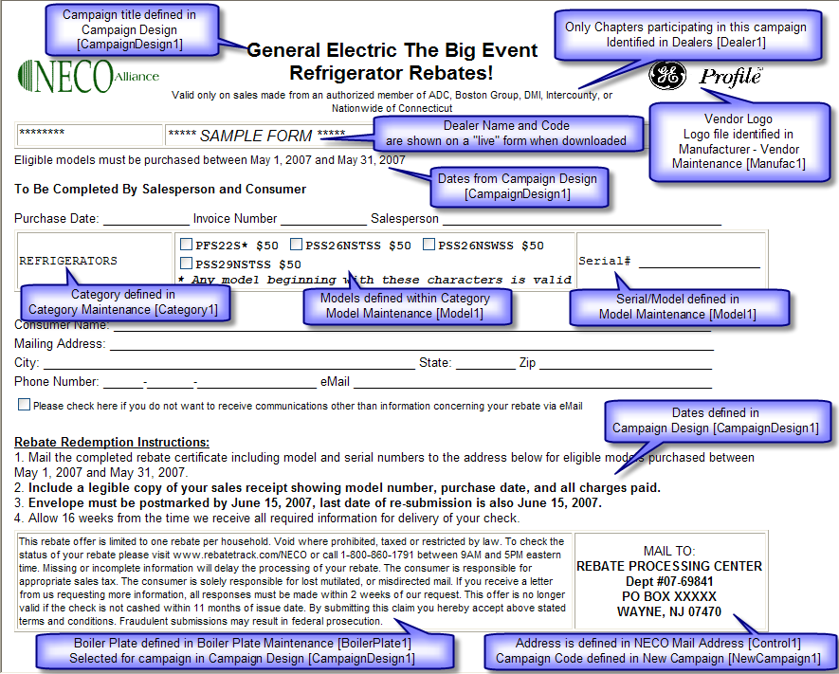

By using this “building block” approach, the Rebate System is capable of building and displaying a wide range of rebate qualification rules and implementing them in a consistent, easy to use, data entry, invoicing, check writing and consumer inquiry way.

The following rebate qualification rules are implemented within the system:

- Amount with each model – a rebate amount is identified for each model
- Package – a rebate amount is paid based on the number of models purchased
- Package with Bonus – a rebate amount is paid based on the number of models purchased and a bonus rebate is also paid if a minimum of a specified number of models is purchased
- Some models paired – in addition to a rebate being identified for some models, other models may be grouped as a “pair” with the qualification rule that the consumer must purchase one model from each of the groups within the pair. For example, a washer and dryer pair.
- Specific package with Bonus Models – qualification rules are established for models within various categories must be purchased in specific and/or combinations. For example, a purchase of a range or a refrigerator and a dishwasher. In this rebate offer, it is possible to define the rebate amount as determined by the consumer purchasing another category. For example, if the consumer purchases a range or a refrigerator and a dishwasher the rebate amount is determined by the purchase price of a cooktop purchased at the same time.
- Variable package – qualifications rules require that the consumer purchase a model from each category in the campaign (a category may consist of individual models, a pair, or consist of sub-categories). The rebate reward in a variable package is based on the purchase price of a model in a designated category, and the rebate reward price can have a maximum amount associate with it.

In addition the following can be defined in any rebate campaign:
- a maximum total rebate amount to be paid
- a minimum purchase price for a specific model, or pair, or package
The following rebate descriptions can be used independently as reference, or if read in order, as a tutorial of the various capabilities and definitions within the rebate system.

Amount with each model
The amount with each model has been the most commonly used rebate program. This program has a specific rebate amount associated with each model in a category.

Rebate Form
Note the use of the * at the end of a model number, will cause the italics comment at the end of the models listed for the category * Any model beginning with these characters is valid

Also note that in the model/serial section of the rebate form there is no space shown for the consumer to write-in the model number – checking the model in the model description area is sufficient. Also, only one serial # entry is provided.

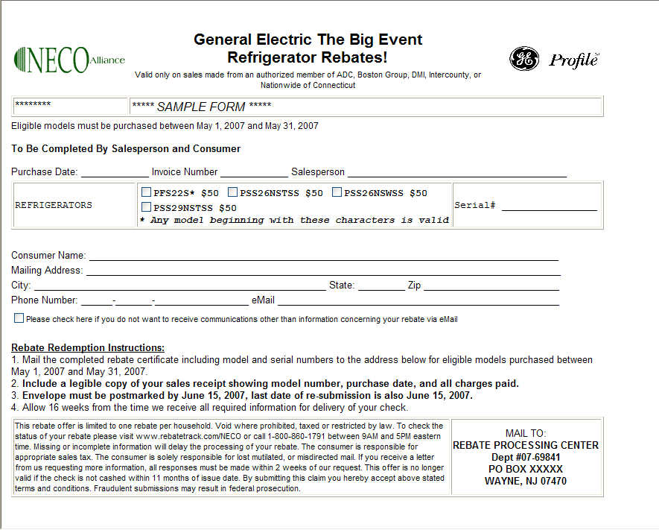

Package with Bonus

Rebate Form

Points to note:

- A “Header” is shown above the Category / Model / Model-Serial Number section, providing information to the consumer
- Model-Serial Number information is not shown for each category, but is shown at the bottom of the Category / Model section – this conserves space on the form to allow it fit on one page
- Additional information is shown below the models in the Built-in Refrigeration category.
- No rebate amounts appear next to the models, because this is a Package campaign.
- Line Spacing has been set to 0 to remove extra lines between Purchase Date / Invoice Number / Salesperson section and the Category / Model section, and between the Category / Model section and the Consumer information, and between the Consumer Information and the Rebate Redemption Instructions, and between the Rebate Redemption Instructions and the Boiler Plate.

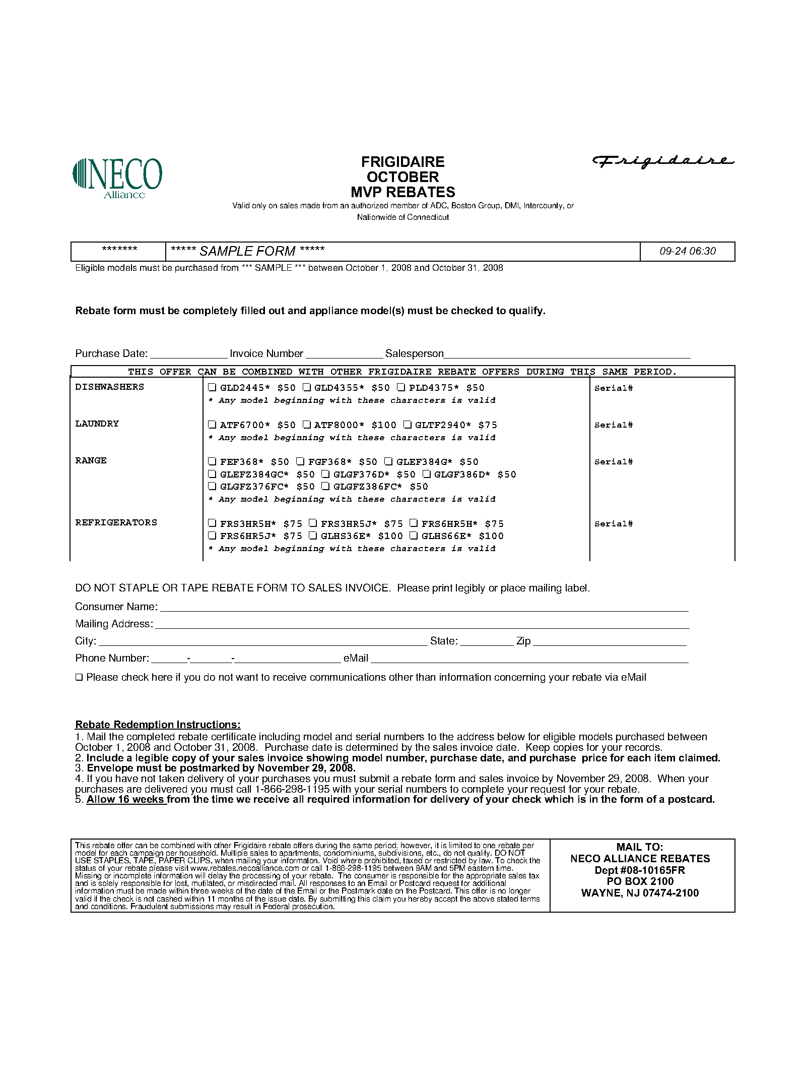

Some Models Paired

Rebate Form

Points to note:
- Laundry Pair of Washer/Dryer category, requires the consumer to purchase a washer and a dryer to qualify for the rebate.
- Two sets of Model/Serial information to entered by the consumer of the Laundry Pair
- Extra spacing between rebate form sections to improve the formatting of the rebate form on one page.

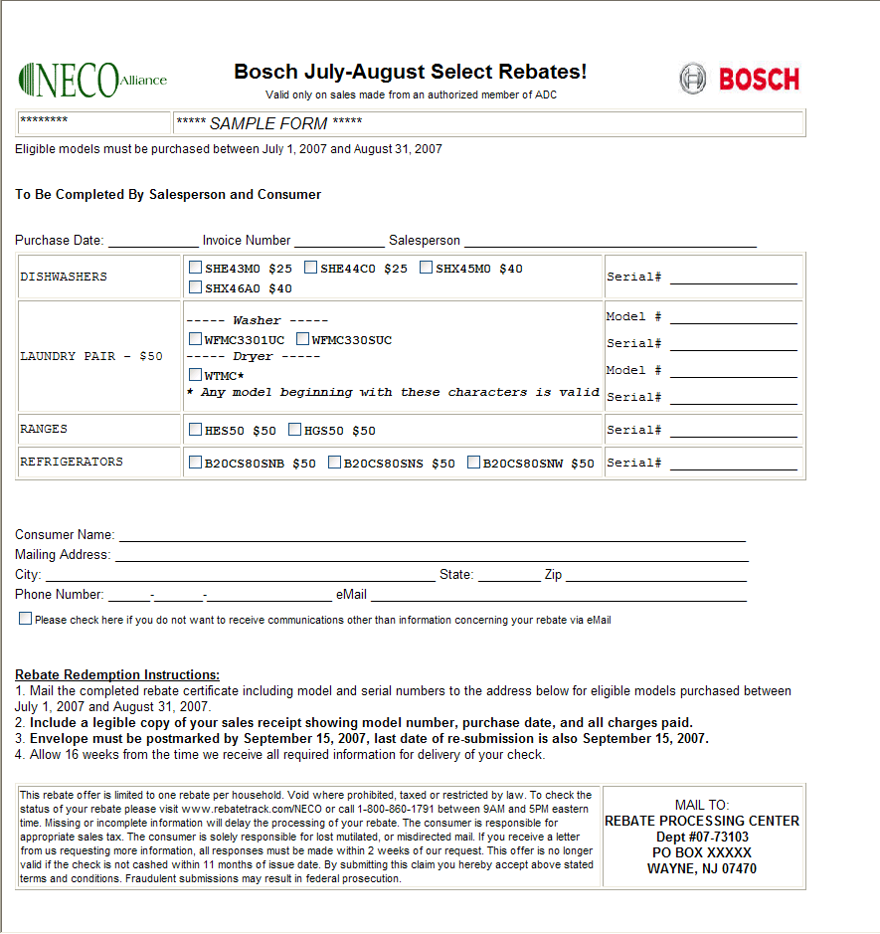

Specific Package with Bonus Models

A Specific Package is a rebate campaign where the consumer must purchase a model from a specific category (the qualification criteria can be established to require the consumer to require multiple categories of product).

Rebate Form

Points to note:
- Header and Footer information which appears above and below the category/ model/serial information to explain the campaign
- The category TV appears before the Home Theatre System category. Normally categories are listed in alphabetical order, however this rebate form shows TV first – this is done to make the rebate form more understandable by having the required (specific) category before the “bonus” category (which will only be paid when a qualifying TV model is purchased)
- Additional explanation under the models in the TV category to explain the campaign.

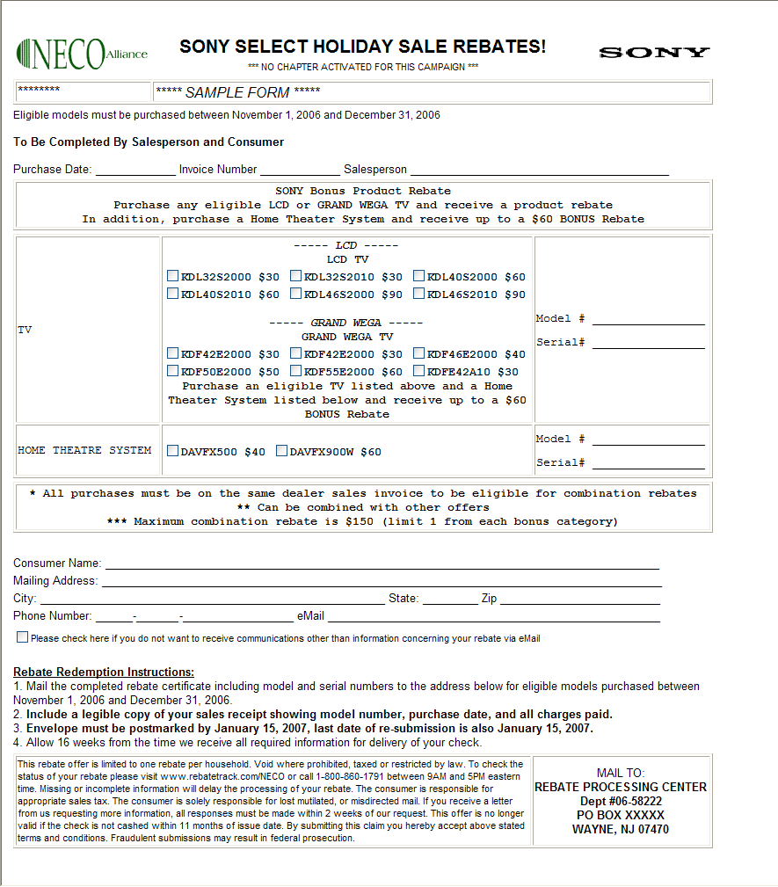

Variable Package
A Variable Package requires that the consumer purchase a model from each category (a category may be a pair or consist of sub-categories). The rebate reward in a variable package is based on the purchase price of a model in a designated category, and the rebate reward price can have a maximum amount associate with it.

Rebate Form
Points to note:
- The form spans two pages, and has the category / model information on the second page.
- The category / model information is shown in “compressed” format to save space
- Header text is used to explain the campaign
- Page footer/heading showing campaign name and page number

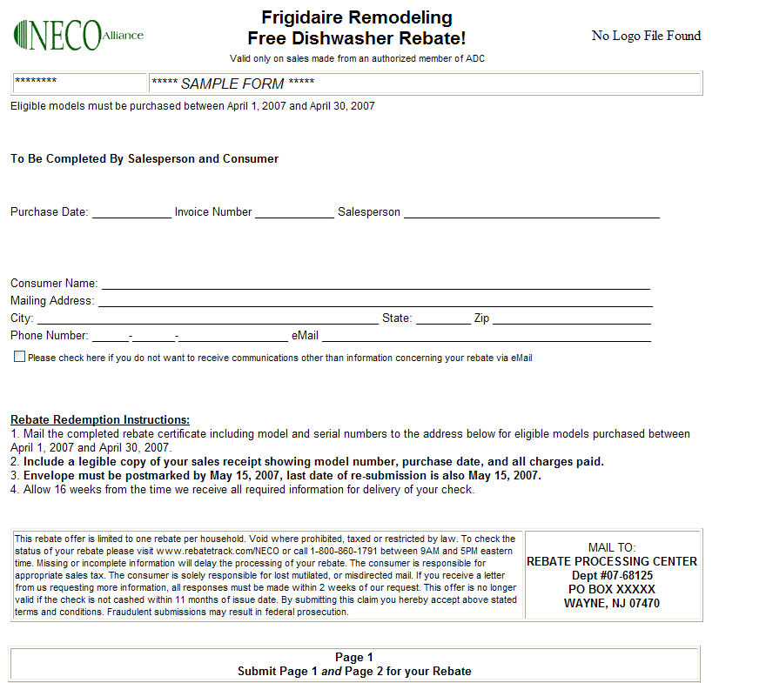

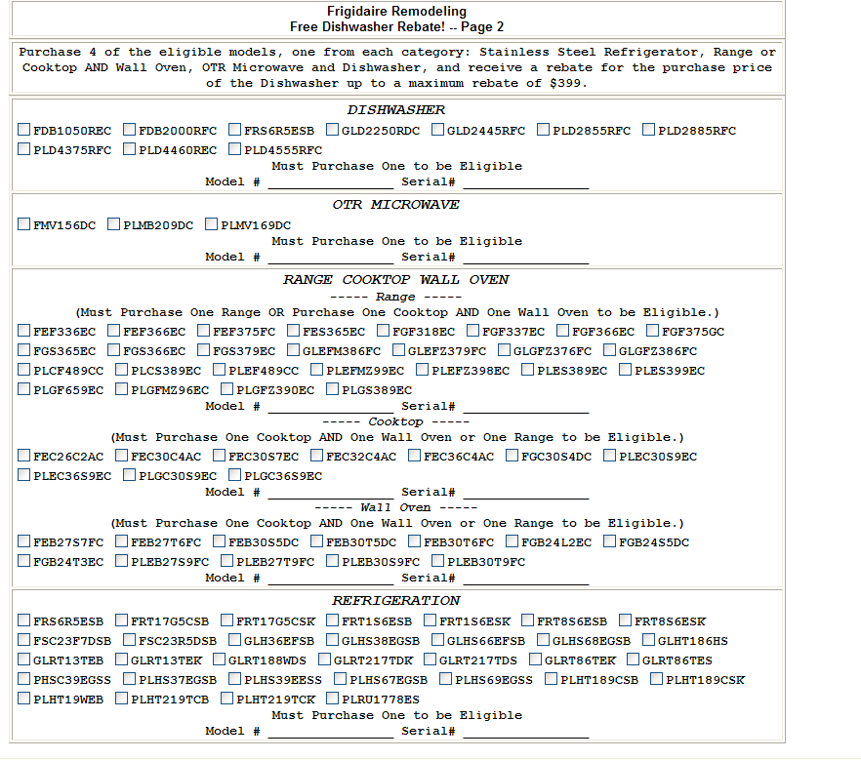

Detail Processing

Login Processing

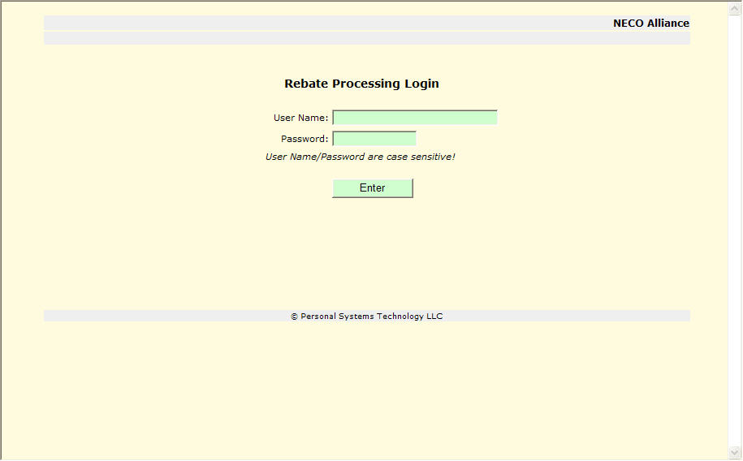

User login. User Name and Password are case sensitive.

The User Password must be 8-14 characters with a least one lower case letter, one upper case letter and one of the following special characters: !@#*+= If a User enters an incorrect password three times on the same day, the system will automatically suspend user rights and instruct the user to contact a Rebate System Administrator to have their password reset. The system will automatically require a new password to be created when a system determined time has elapsed.

The User Password for chapter members will be maintained and authorized on a real time basis through a single password sign-on facility managed by Retail Deck.

Menu

The “Main Menu” will appear on each screen after proper login.

The user can select from the menu what key activity to use:
- Campaigns
  - Preview, Active – campaign forms and reports – access in either oldest first or newest first
  - Closed, Archived – campaign forms and reports – access in either oldest first or newest first
  - Discussion – allows for the online discussion of campaign changes
- Process
  - Activity – create reports of Rebate activity for a period
  - Cycles – create downloadable spreadsheet of rebate activity for a NECO billing cycle
- Membership – used by the chapter administrator to identify changes in membership
  - Inquiry – look up / review of entered consumer. Inquiry can be performed by Tracking Number, Telephone Number, or Last Name and Zipcode. Last Name and Zipcode searched can be made with partial information. A percent sign (%) is the wildcard character for partial information inquiries.
- Email Maintenance – add / update / delete email addresses of Chapter personnel who should receive email notification of new or changed rebates
- Portal
  - View reports/spreadsheets of manufacturer sales-in data
- Logoff – logs user off of the Rebate System
- If there is any outstanding items requiring the user’s attention for campaign discussion, *** Campaign Discussion *** will appear highlighted in red on the menu.

Campaigns
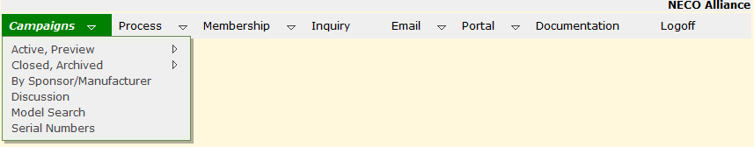

Campaigns which are in Preview (not yet available to NECO members) and Active (campaigns which are currently available for consumer purchase), and campaigns which are Closed (no longer available for consumer purchase, but all activity not yet completed) and Archived (campaigns where all activity has been completed) may be accessed for forms and reports.

By Sponsor/Manufacturer provides selected lookup of campaigns by an individual sponsor/manufacturer (provides a quicker, shorter lookup).

Discussion provides access to the Discussion forum for campaigns.

Model Search allows for the search of campaigns to determine when a specific model is eligible.

Serial Numbers provides a downloadable spreadsheet of serial number claimed for rebate during a specific purchase period.

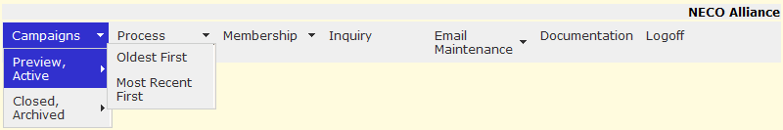

In Preview, Active; select Oldest First or Most Recent First and control will transfer to Preview, Active [CampaignSelect3] to list campaigns in the order selected.

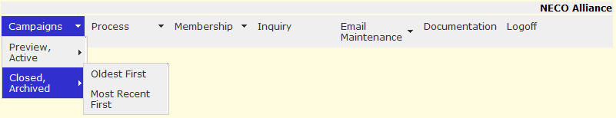

In Closed, Archived; Select Oldest First or Most Recent First and control will transfer to Closed, Arcihived [CampaignSelect3c] to list campaigns in the order seleted.

Preview, Active [CampaignSelect3]

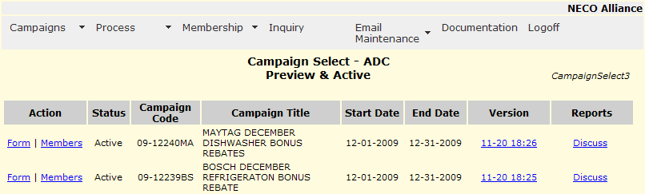

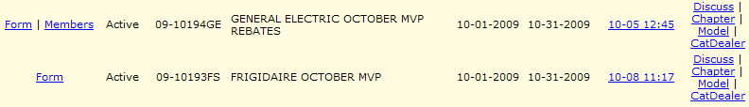

All Rebate Campaigns in Preview, Design or Active state are listed in chronological sequence. If the are more than 15 campaigns then VCR like controls will be present to allow for the scrolling of all campaigns.

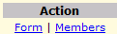 To take action on this campaign select:
- Form will open a secondary window and display the rebate form for this campaign, right mouse click on the secondary window and select “Print” to print a local copy.
- Members will be displayed if your chapter has been authorized to participate in this campaign. Remove selected members from participating in this campaign or add members who had previously been removed from this campaign participation. Control will transfer to Dealer Processing [Dealer2].
- Change List will be displayed if you chapter has been authorized to participate in this campaign AND the campaign is currently in “Preview” state. If selected, control will transfer to Change Campaign Member List [MemberList7].

of campaign

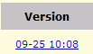 displays the current time date stamp version of this rebate. Selecting the time/date stamp will display the campaign change history. Control will transfer to Campaign History [CampaignHistory1].

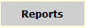
Discuss will transfer to CampaignDiscussion [CampaignDiscuss1] and allow for online discussion of campaign discussion
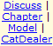 if there have been Rebates entered for this campaign Reports selection will appear.
- Chapter will display a comparative report of all NECO chapter participation in this campaign. Further drilldown into your chapter to show member participation in this campaign. NECO Report By Chapter [NecoReportByChapter]
- Model display a summary report of information by model for this campaign. Transfer to NECO Report By Model [ModelReport2]
- CatDealer will download a spreadsheet of category sales by dealer for the campaign

Closed, Archived [CampaignSelect3c]

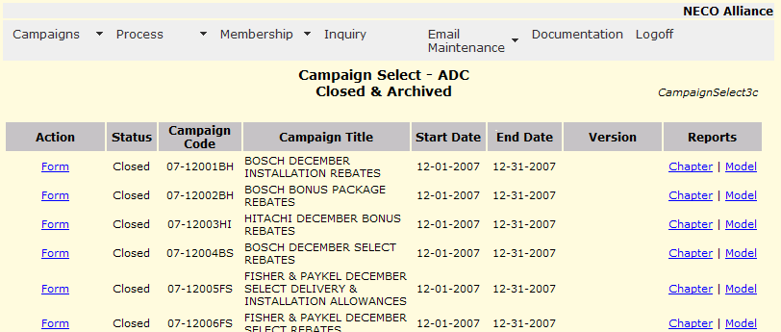

All Rebate Campaigns in Closed or Archived state are listed in chronological sequence. See screen CampaignSelect3 for a complete description of usage.

Campaign History [CampaignHistory1]

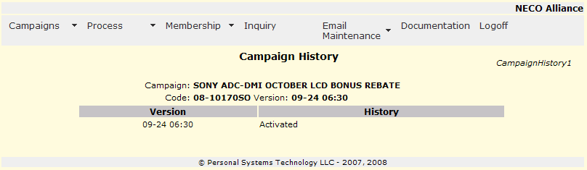

The history of changes to this campaign are shown, the most recent change first.

By Sponsor/Manufacturer [CampaignSelect10]

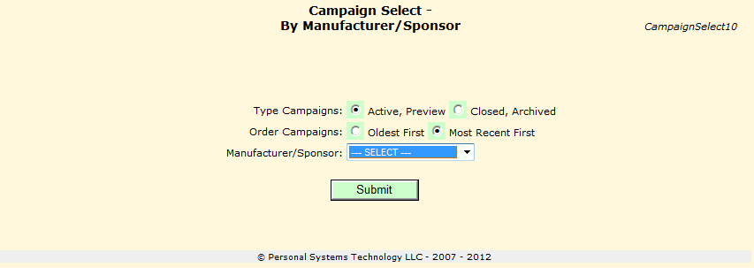

- select the campaign type
- select the order you would like to see the campaigns listed in
- select from the drop down list which manufacturer/sponsor you would like to search for
- 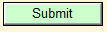press submit and control will transfer to CampaignSelect3 or CampaignSelect3c to view the campaigns selected.

Campaign Discussion – Overview

Campaign Discussion provides for easy communication and review of rebate campaigns. It provides for communication between the rebate system administrator, NECO merchandising coordinator, Chapter merchandisers and Manufacturers.

If there are comments for any campaign which you have not viewed, a “campaign discussion” reminder will appear on the top banner of all screens in the rebate system.

The main entry to the Campaign Discussion is through the Campaign Review Discussion screen [CampaignDiscuss1] which is selected from the “Discussion” selection on the system menu (the NECO merchandising coordinator, and the NECO chapter merchandisers access this under “Campaigns” on the main menu, Manufacturers access “Discussion” directly from the main menu).

Also, campaigns which have comments associated with them which you have not reviewed will be highlighted in your Campaign Select list (from the menu selection).

You can create comments for a campaign which is currently not part of the Campaign Discussion by going to Campaign Select and selecting the “Discuss” selection on that campaign entry.

Campaign Review Discussion [CampaignDiscuss1]

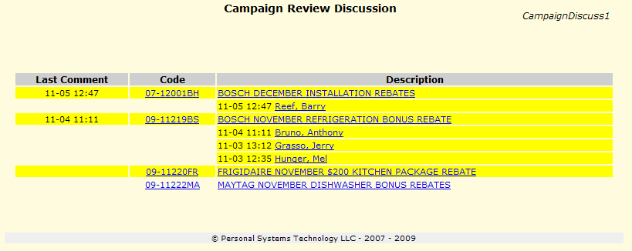

Campaigns are listed in campaign code order sequence (oldest campaigns first). If there are comments (or a campaign has been posted in Preview) that you have not yet reviewed, the campaign is highlighted in yellow. If there are comments posted regarding a campaign, the date/time stamp of the most recent comment is listed under “Last Comment”. Each individual who has made a comment to a campaign is listed in alphabetical order with the date/time stamp of their most recent comment.

Actions:
- 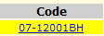 (campaign code used for illustration only) selecting the campaign code will display [CampaignDiscuss2] a facsimile of the rebate form, all comments in chronological order (most recent first) and allow you to add your comment for others to see. Selecting this choice will remove your highlighting of this campaign the next time you return to this screen. The campaign will be highlighted the next time that you view this screen if another individual has added a comment.
- (campaign name used for illustration only) selecting the campaign name will open a new window and display a sample of the actual rebate form for this campaign.
- (individual name, date/time stamp for illustration only) selecting an individual who has made a comment will display Campaign Discussion – individual [CampaignDiscuss4] which will show only comments made by this individual regarding this campaign in chronological order with the most recent comment first. You can add your own comment which all other reviewers will be able to see and this campaign will be highlighted on the other reviewers screens to indicate that a change has occurred.

Campaign Discussion – Facsimile [CampaignDiscuss2]

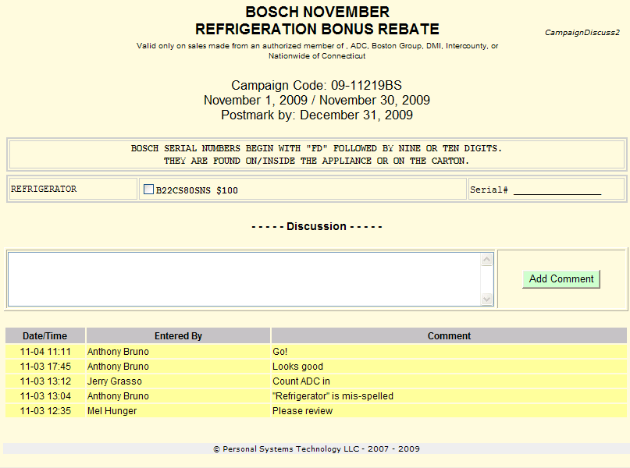
Shows a facsimile of the rebate form (all pertinent information is displayed, but the formatting may be slightly different). The top of the screen displays:
- Campaign name
- Chapters which have been activated to participate in the campaign
- Campaign code
- The date range when the campaign is active.
- The postmark date by which all submissions must reach the NECO Rebate office.
- “Header” information may be present to provide a further description of the campaign
- The models grouped within categories for the campaign with any additional information which may be pertinent to this campaign.
- “Trailer” information may be present to provide further description of the campaign

Following the facsimile of the rebate form is the “Discussion” area. It is here that you can add comments which all other reviewers will see. A comment can be up to 1000 characters and you must select “Add Comment” after you complete your comment entry for it to be visible to others. Adding a comment will cause this campaign to be highlighted on all other reviewers screens when they review campaigns. When you select “Add Comment” this screen will be re-displayed and you will see your comment appended to the top of the “discussion” list.

Last, all previous comments for all individuals regarding this campaign will be displayed in chronological order, with the most recent comment first.

Campaign Discussion – individual [CampaignDiscuss4]

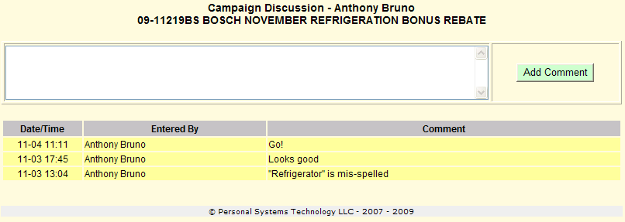

This screen shows all comments by the selected individual for this campaign in chronological sequence with the most recent first.

You can add your own comment (up to 1000 characters) and when you select “Add Comment” you will be transferred back to Campaign Discussion – Facsimile [CampaignDiscuss2] with your comment added. Also, all other reviewers will now see your comment and this campaign will be highlighted in their list of campaigns.

Model Search [ModelSearch3]

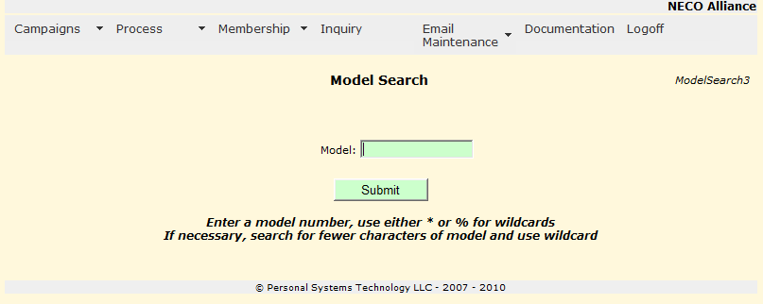

Model Search provides a lookup of models used in all current and past campaigns. The search criteria may be as specific (i.e. SHE43P02UC) or generic (i.e. SHE43*) as desired. But be aware that frequently model identification is stated generically on rebate forms, so it is recommeded that if you intially search using specific criteria and do not locate the model you are searching for to then use a generic search.

- enter the model information to be searched. Use either a * (asterisk) or a % (percent sign) to represent a wildcard for all following characters.
- Select submit and control will transfer to Model Search [ModelSearch4].

Model Search [ModelSearch4]

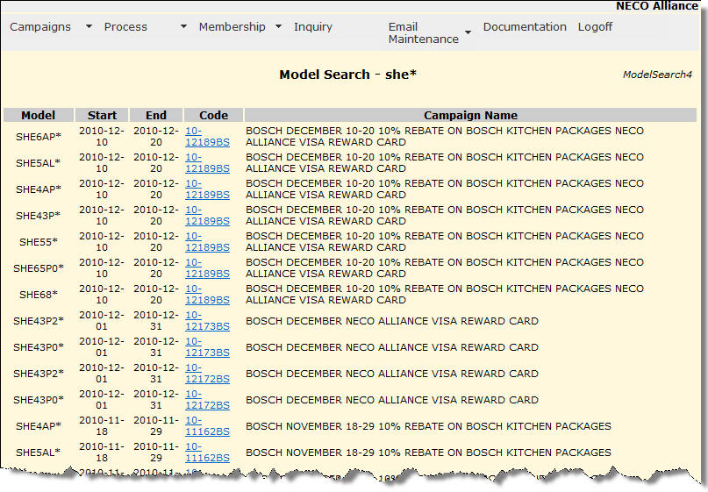

A partial display of a search for the generic model she* is shown. Note: the models are displayed in model alphabetical order as shown on rebate forms beginning with the most recent campaign start date and then progressing through older campaigns.

- 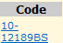 Select the code of any displayed model to open a secondary window with a sample form displayed of the campaign.

Serial Numbers [ChapterSerial1]

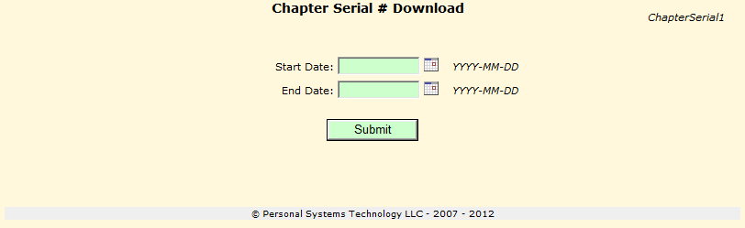

Serial Numbers will create a downloadable spreadsheet of information which allows a chapter to verify the serial numbers of claimed rebates were shipped from their warehouse. The date selections represent the purchase date stated on the member’s sales invoice. Be aware that rebates are often submitted up to 30 days after the purchase date, and serial numbers are not available until merchandise is shipped to the consumer. That stated, the user should be aware that a selection of dates close to today’s date will likely not yield all purchases which have occurred. A more accurate assessment can be made when querying for dates at least 60 days past today’s date.

- either click on the calendar icon to select a start date, or enter the date in YYYY-MM-DD format.
- either click on the calendar icon to select a end date, or enter the date in YYYY-MM-DD format.
- press submit and an Excel spreadsheet will be downloaded with information for the time period selected.

Process

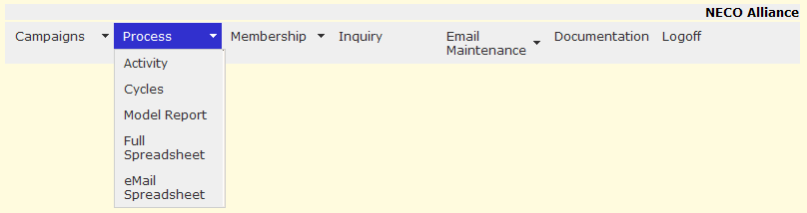

Reports by activity period or spreadsheets by cycle period, models information by calendar period, full mailing addresses or eMail addresses are available.

If Activity is selected control will transfer to Activity for reports by chapter, manufacturer, and member with ability to drilldown for further detail (control will transfer to Activity.

If Cycles is selected a spreadsheet of all activity for a billing cycle can be downloaded (control will transfer to Cycles).

If Model Report is selected control will transfer to Chapter Model Report for reports by model for a specific manufacturer for a calendar period.

If Full or eMail spreadsheet is selected a spreadsheet of mailing addresses or email addresses will be downloaded (control will transfer to Full / eMail Spreadsheet).

Activity [ReportActivity2]

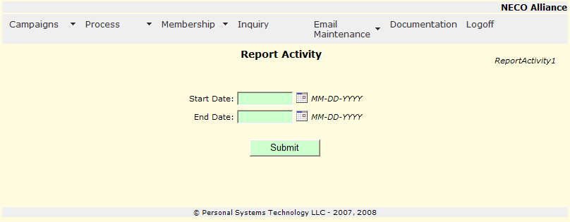

- 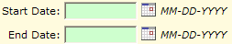 enter the dates for the report in MM-DD-YYYY format or click the calendar logo and pick the dates from the secondary calendar window
- 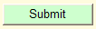 the report for execution, transfer to Chapter Summary [ReportActivity5]

Chapter Summary [ReportActivity5]

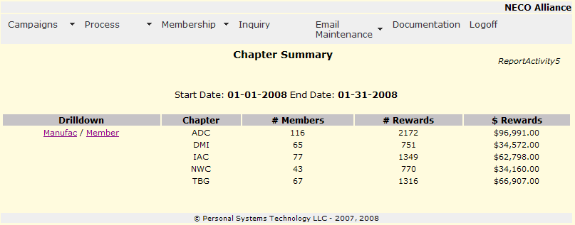

A report is generated based on the calendar dates and chapter selection of Report Activity [ReportActivity2]. Details by chapter, number of members with rebate activity and the number of rebates along with dollar rebates.

- 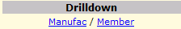 to drill-down by manufacturer or member will appear for your chapter
  - Select Manufac to create a report by manufacturer and transfer to Manufacturer Summary [ReportActivity6]
  - Select Member to create a report by member and transfer to Member Activity [ReportActivity7]

Manufacturer Summary [ReportActivity6]

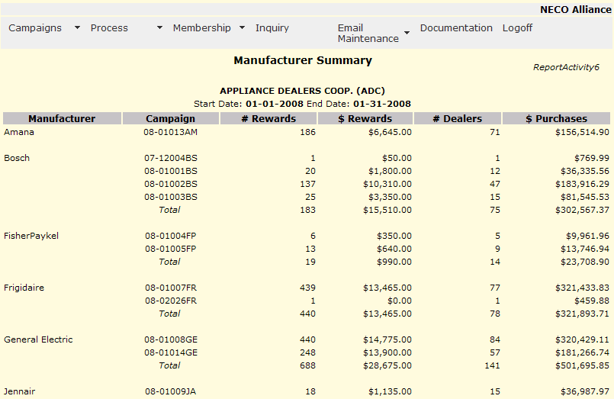

All manufacturer activity summarized by Rebate Campaign for the calendar period requested is displayed.

Manufacturer activity is totaled if more than one campaign is present.

Member Activity [ReportActivity7]

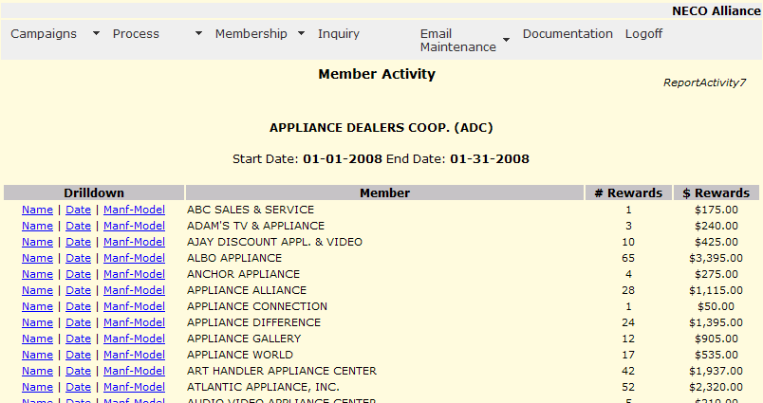

To further drill-down for specifics of rebate activity within the date range

- 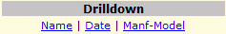 Select category to show consumer activity by
  - Name – transfer to Member Detail-Consumer [ReportActivity9]
  - Date – transfer to Member Detail – Date [ReportActivity10]
  - Manf-Model transfer to Member Detail – Manufacturer/Model [ReportActivity11]

Member Detail – Consumer [ReportActivity9]

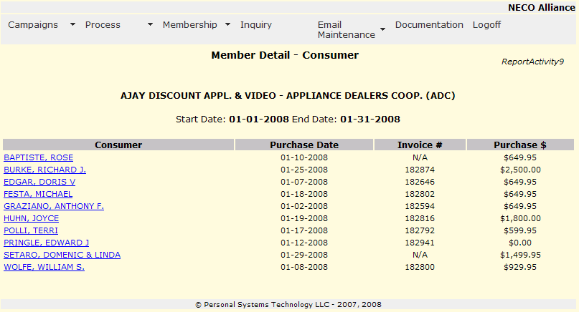

To display consumer detail, select the consumer name and transfer will be made to Rebate Inquiry [RebateInquiry5]

Member Detail – Date [ReportActivity10]

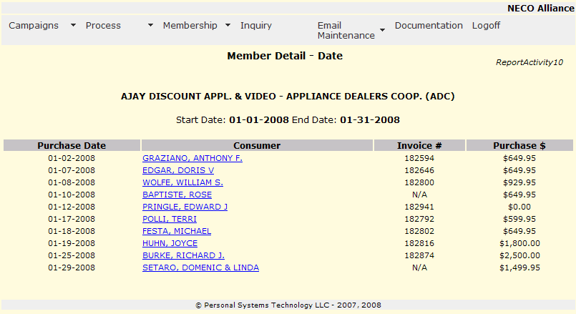

To display consumer detail, select the consumer name and transfer will be made to Rebate Inquiry [RebateInquiry5]

Member Detail – Manufacturer/Model [ReportActivity11]

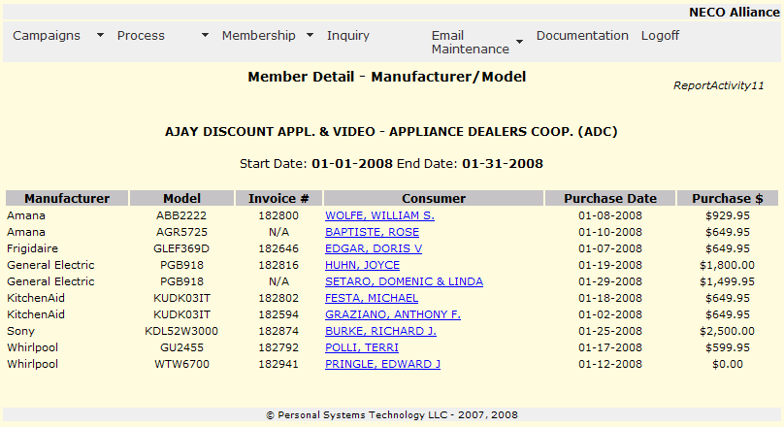

To display consumer detail, select the consumer name and transfer will be made to Rebate Inquiry [RebateInquiry5]

Cycles [ChapterCycle1]

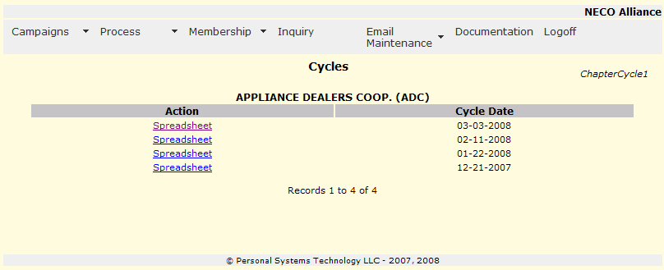

Shows the billing cycles that have occurred.

- will download a billing detail spreadsheet for the cycle date selected.

Chapter Model Report [ChapModelReport1]

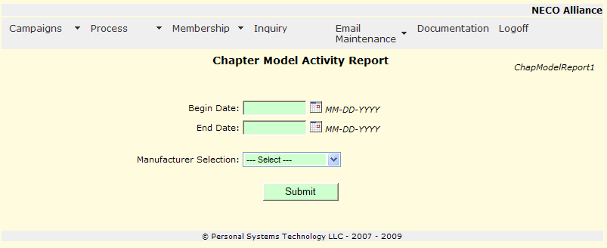

Select a calendar period and a manufacturer to produce a report or spreadsheet of model activity.

- enter date to begin report
- enter last date of report
- select a manufacturer from the pull down list
- control will transfer to Chapter Model Report [ChapModelReport3].

Chapter Model Report [ChapModelReport3]

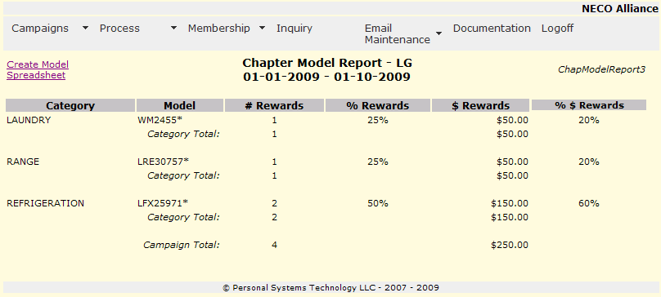

A model report for the specified time period and manufacturer is created summarizing activity by category/model with details on the number and dollars of rewards and percent of all rewards and percent of dollars of rewards.

- select to download a spreadsheet of this report.

Full / eMail Spreadsheet [CustomerList1]

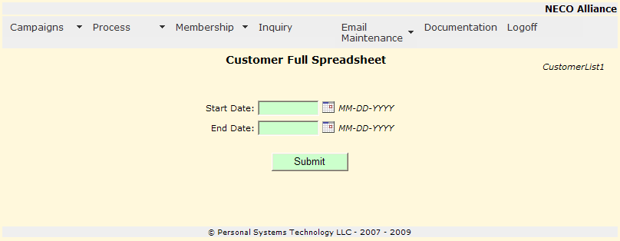

The user may select either a Full Spreadsheet (which contains standard mailing address information) or eMail Spreadsheet (which contains just email addresses) along with purchase information.

- enter the start date range for processing
- enter the end date range for processing
- the Full or eMail only spreadsheet will be downloaded.

Membership

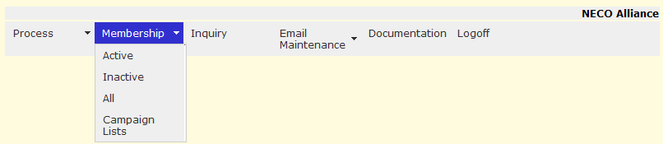

Chapter Membership maintenance.

All will display Active and Inactive members, Active will only display Active members, Inactive will display only inactive members. All, Active, and Inactive all function in a similar way.

Active/Inactive/Total member counts will be listed under the chapter name.

Campaign Lists provides the ability to create and maintain specific lists of members to be used in campaigns. For example a list of Bosch authorized dealers can be created and then used in Bosch campaigns. Any number of Campaign Lists can be created.

Chapter Member Maintenance – Active Members [MemberMaint1]

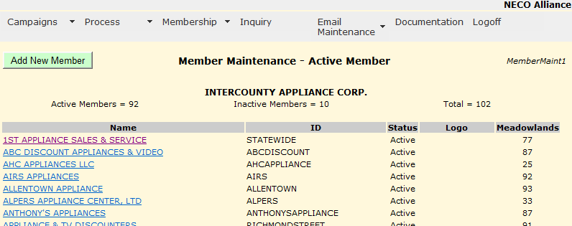

Displays active members of your chapter.
- add a new member to the chapter. A new member record is added and control is transferred to Chapter Member Maintenance [MemberMaint2]. When a new member is added, the Rebate System will scan for all campaigns which are in Preview or Active state where this chapter is currently participating and a entry will be made to add this new member as a participant in the campaign.
- 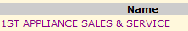 select a member name for update. Control will transfer to Chapter Member Maintenance [MemberMaint2]

Chapter Member Maintenance [MemberMaint2]

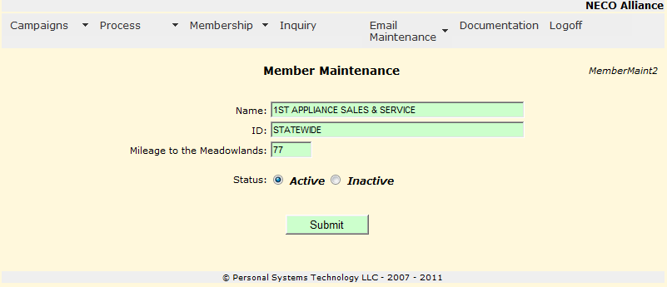

- enter member name

- member ID

- select member/chapter status

- enter the driving mileage from the member store location to the Meadowlands Convention Center. This mileage calculation is use for NECO Spring Show registration to determine if a hotel room for the show night will be paid for by NECO.

- to record chapter member changes

Campaign Member Lists [MemberList1]

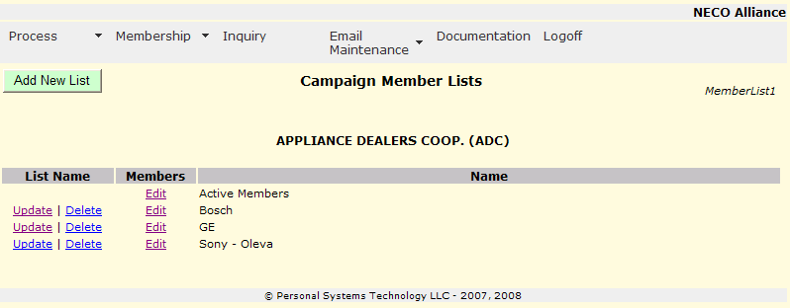

All currently defined Chapter Member Lists appear in alphabetic sequence.

The “Active Members” list will always be the first entry.

- to add a new named Chapter Member List. Control will transfer to Campaign Member Lists – Add/Update List Name [MemberList2].
- will allow for the adding and deleting of Chapter Members to this named Member List. If selection is made on “Active Members” control will transfer to Chapter Member Maintenance – All Members [MemberMaint1]; if selection is made on any other named Member List control will transfer to Campaign Member List – Maintenance [MemberList5].
- 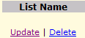Update allows you to change the List Name of this Member List, control will transfer to Campaign Member Lists – Add/Update List Name [MemberList2]. Delete allows you to delete the selected named list, control will transfer to Campaign Member List – Delete List [MemberList4]. NOTE: deleting a Member List will remove the named Member List, but it will not affect any campaigns which have selected this member list for use (i.e. existing campaigns which have used this member list will remain with the Chapter Members which were selected).

Campaign Member Lists – Add/Update List Name [MemberList2]

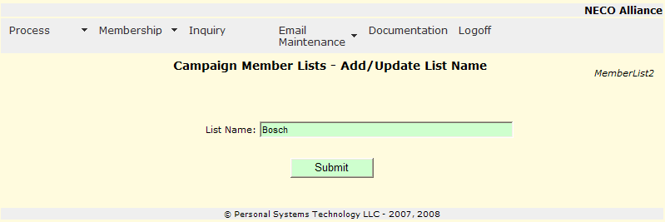

- Add or update the name you would like for this Chapter Member List. List Names can be up to 50 characters – use a name that will be descriptive for your ease of use.
- to cause the List Name to be updated in the Rebate System, and control will transfer to Campaign Member Lists [MemberList1].

Campaign Member List – Delete List [MemberList4]

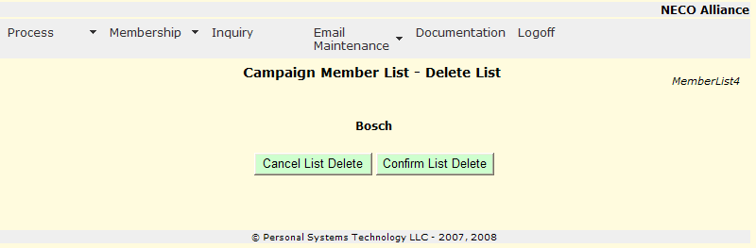

- will NOT delete the Campaign Member List and control will transfer to Campaign Member Lists [MemberList1].
- will delete the selected Campaign Member List and control will transfer to Campaign Member Lists [MemberList1]. NOTE: deleting a Campaign Member List will not affect any campaigns which have used this list to identify participating members, existing campaign member selection remain in force.

Campaign Member List – Maintenance [MemberList5]

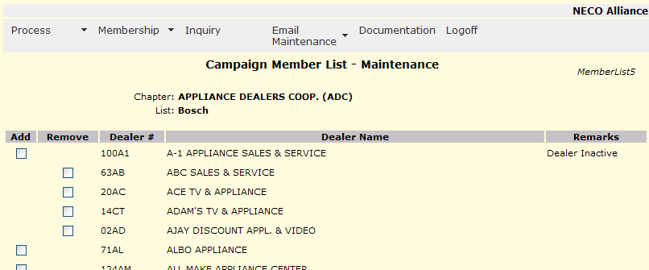

A list of all members of the chapter is displayed. If a dealer is “active” in a chapter, and not participating in this Chapter Member List, an “Add” checkbox will appear for the Dealer. The “Remove” checkbox will appear is the Dealer is participating in the Chapter Member List.

Checking either the “Add” or “Remove” checkboxes for any number of Dealers and the clicking “Submit” the dealers will be added/removed from the current Member List.

- 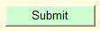 should be selected to process all add/remove selected activity

Inquiry

Rebate Inquiry [RebateInquiry1]

Inquiry (lookup) of consumer rebates can be done in three ways:

- A lookup of the 12 position tracking number
- Consumer phone number
- A search lookup of full or partial last name and zipcode

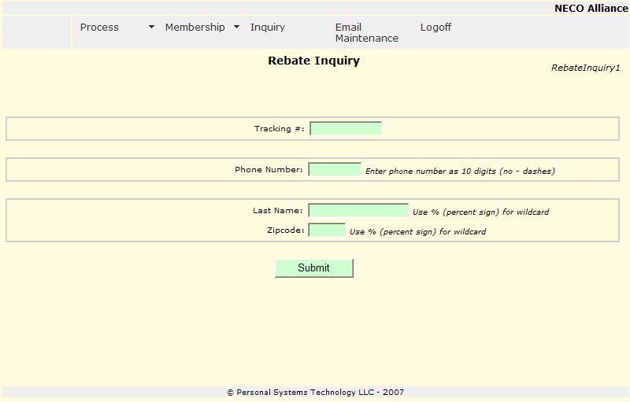

- if Valid rebate display on Rebate Inquiry [RebateInquiry5], in Pend or Reject display for update on Rebate Input [RebateInput5]
- if Valid rebate display on Rebate Inquiry [RebateInquiry5], in Pend or Reject display for update on Rebate Input [RebateInput5]
- 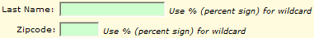 entry may be made in upper or lower case, to search using a wildcard use the percent sign “%”, a list of found entries is displayed on Rebate Inquiry – Name/Zipcode Lookup [RebateInput4]
- 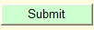 to begin the lookup

Rebate Inquiry – Name/Zipcode Lookup [RebateInquiry4]

A list of rebates meeting the search criteria is displayed in alphabetic sequence.

If there are more than 15 rebates, than VCR like controls will be present for scrolling.

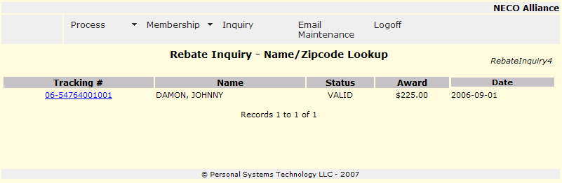

- 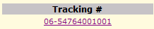 select the tracking number for the entry to be displayed. If Valid rebate display on Rebate Inquiry [RebateInquiry5], in Pend or Reject display for update on Rebate Input [RebateInput5]

Rebate Inquiry [RebateInquiry5]

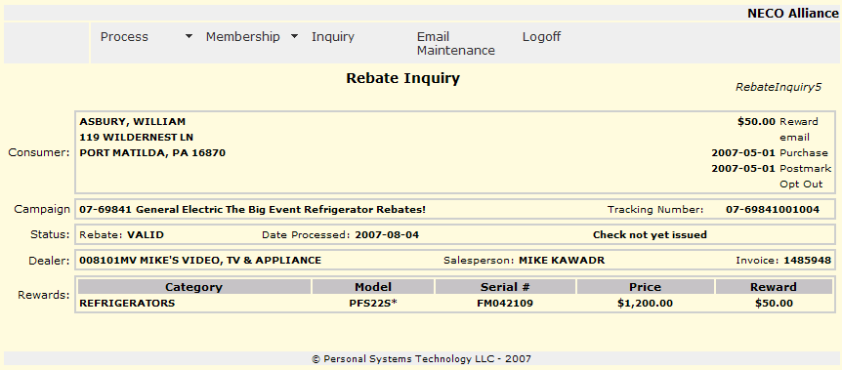

Email Maintenance

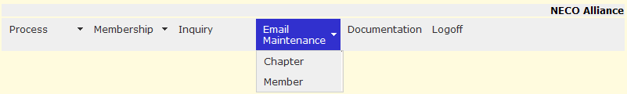

Additional Email addresses may be added / deleted / updated for Rebate System Notifications. The Rebate System communicates via email for Campaigns which are available for Preview, Campaigns which are entering an Active state and for other rebate campaign communications.

Select “Chapter” to work with email addresses for Chapter staff personnel, control will transfer to Chapter Email Maintenance [ChapterEmail1].

Select “Member” to work with member email addresses, control will transfer to Dealer Email Addresses [DealerEmailList1].

Chapter Email Maintenance [ChapterEmail1]

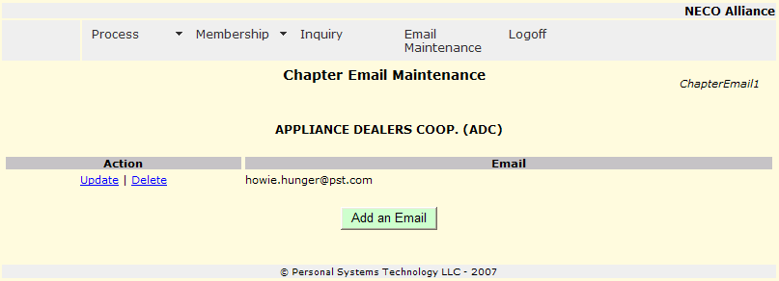

- 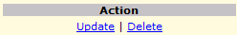 to Update or Delete the currently selected email address
  - Update will transfer to Chapter Email Maintenance [ChapterEmail3]
  - Delete will transfer to Chapter Email Maintenance [ChapterEmail4]
- to add a new email address and transfer to Chapter Email Maintenance [ChapterEmail3]

Chapter Email Maintenance [ChapterEmail3]

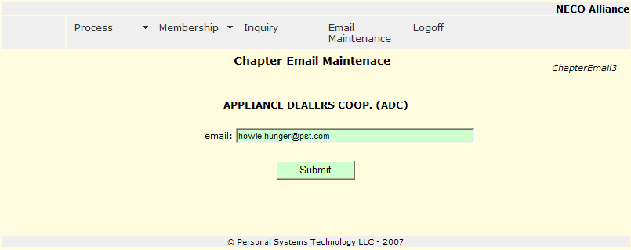

- enter (add/update) an email address
- to record updates and transfer control to Chapter Email Maintenance [ChapterEmail1]

Chapter Email Maintenance [ChapterEmail4]

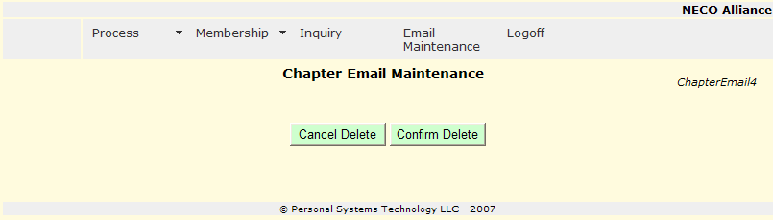

- to cancel to delete of the Email address and transfer control to Chapter Email Maintenance [ChapterEmail1]
- to delete the Email address and transfer control to Chapter Email Maintenance [ChapterEmail1]

Dealer Email Addresses [DealerEmailList1]

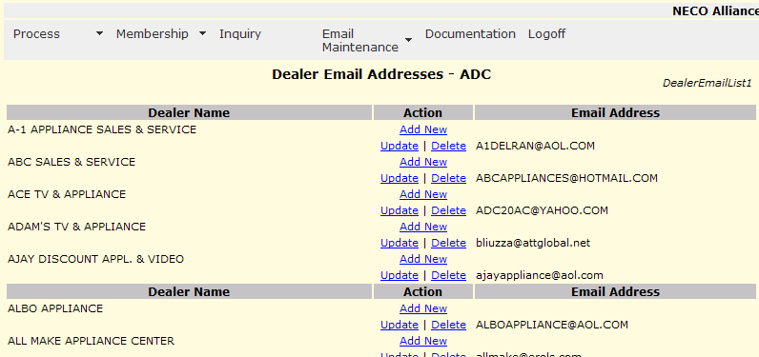

Displays all members and the members email(s) within the selected chapter in alphabetic sequence.

- 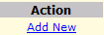 on a members entry will allow you to add a new email address for this member. Control will transfer to Dealer Email Maintenance [DealerEmail3].
- 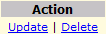on an email entry will allow you to Update or Delete this email entry.
  - Update will transfer to Dealer Email Maintenance [DealerEmail3]
  - Delete will transfer to Dealer Email Maintenance [DealerEmail4]

Member Email Maintenance Add/Update [DealerEmail3]

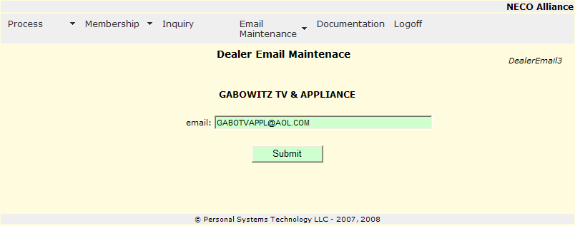

- enter (add/update) an email address
- to record updates and transfer control to Dealer Email Mail Addresses [DealerEmailList1]

Member Email Maintenance Delete [DealerEmail4]

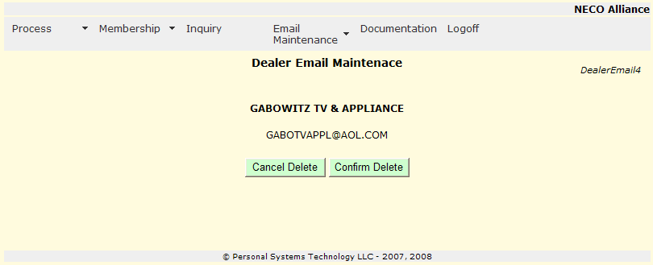

- to cancel to delete of the Email address and transfer control to Dealer Email Addresses [DealerEmailList1]
- to delete the Email address and transfer control to Dealer Email Addresses [DealerEmailList1]

Portal

The NECO Merchandising Portal is only available to authorized individuals.

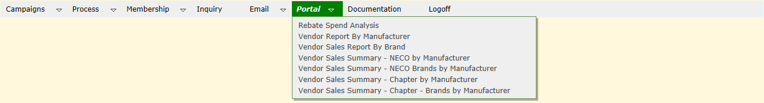

The NECO Merchandising Portal provides information for NECO Merchandisers.

Key functions provided:
- Rebate Spend Analysis
  - Displays a report or download a spreadsheet of the rebate spend analysis
- Vendor Report By Manufacturer
  - Displays a report for a selected manufacturer activity for NECO for a selected period.
  - Control is transferred to VendorSalesReport1
- Vendor Sales Report By Brand
  - Display a report for a selected brand activity for NECO for a selected period.
  - Control is transferred to VendorSalesReport2
- Vendor Sales Summary – NECO by Manufacturer
  - Displays a report of all manufacturers activity for NECO for a selected period.
  - Control is transferred to VendorSalesSummaryReport1
- Vendor Sales Summary – NECO Brands by Manufacturer
  - Displays a report of brands for a selected manufacturer activity for NECO for a selected period.
  - Control is transferred to VendorSalesSummaryReport3
- Vendor Sales Summary – Chapter by Manufacturer
  - Displays a report of all manufacturers activity for a selected chapter for a selected period.
  - Control is transferred to VendorSalesSummaryReport4.
- Vendor Sales Summary – Chapter – Brands by Manufacturer
  - Displays a report of brands within a manufacturer for a selected chapter for a selected period.
  - Control is tranferred to VendorSalesSummaryReport5.

Rebate Spend Analysis [RebateSpendAnalysis3]

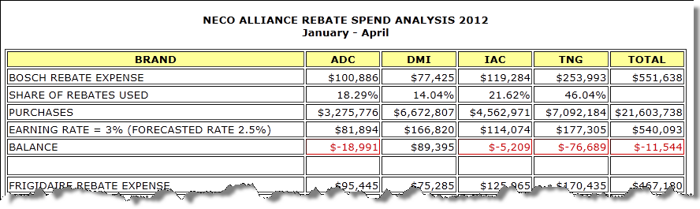
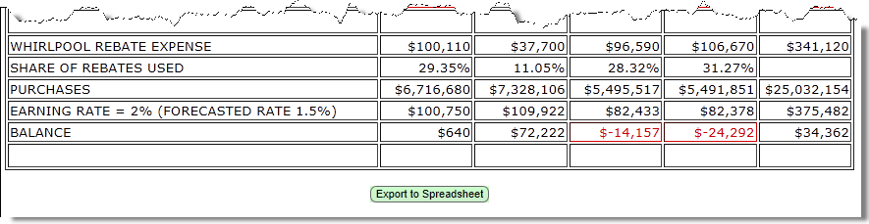

The Rebate Spend Analysis report shows the total dollar rebates spent during the time period of the report (note: remember that the NECO Rebate System is a “live” system – meaning that if you run this report and run it again at a later time the rebate expense information will reflect the most current entered information by the Rebate Center).

Select to download a spreadsheet of this report.

Vendor Sales Report By Manufacturer [VendorSalesReport1]

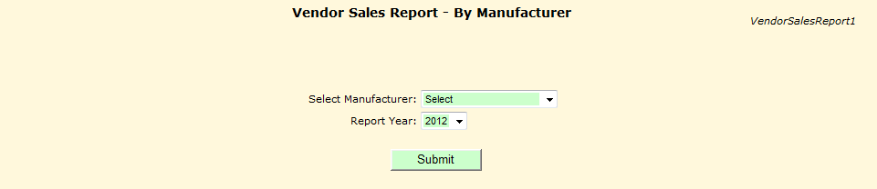

- from the drop down list.
- from the drop down list.
- to create the selected report in a new window, sample below.

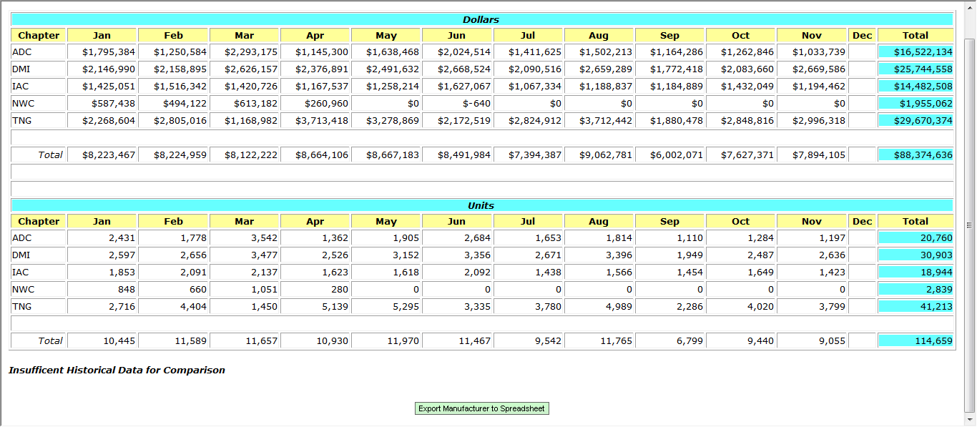

Select to download a spreadsheet showing total manufacturer activity and a separate tab for each brand.
Vendor Sale Report By Brand [VendorSalesReport2]
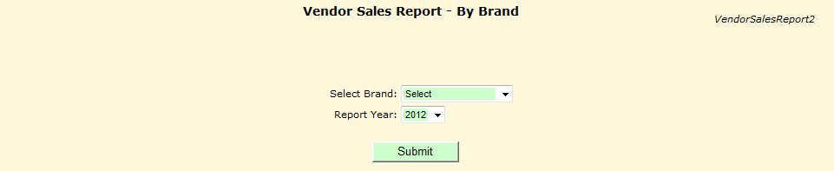

- from drop down list.
- from drop down list.
- 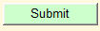 to create the selected report in a new window, sample below.
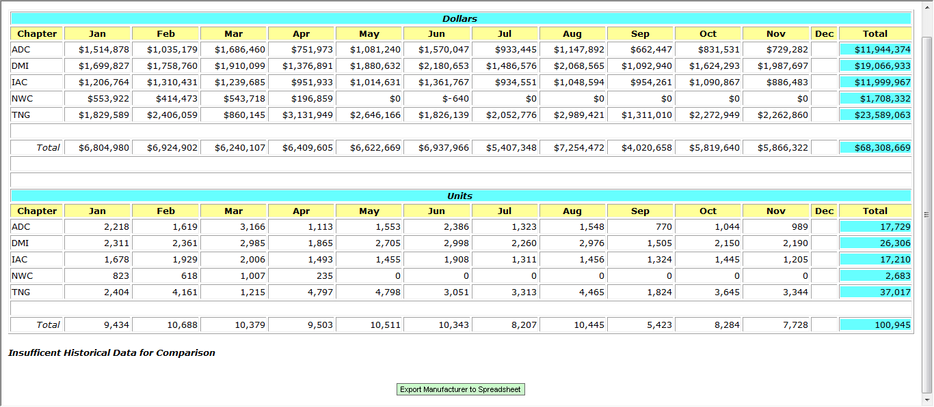

Select to download a spreadsheet showing total manufacturer activity and a separate tab for each brand.

Vendor Sales Summary Report - NECO by Manufacturer [VendorSalesSummaryReport1]

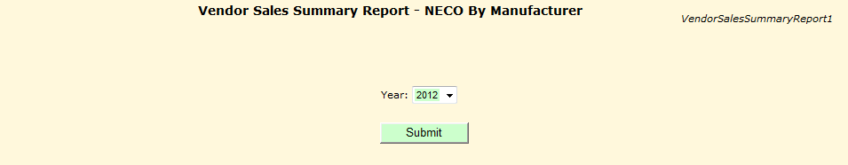

- from drop down list.
- to create the selected report in a new window, sample below.
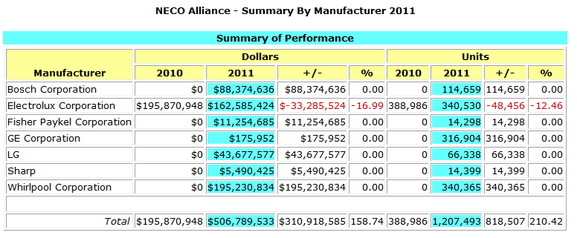

Vendor Sales Summary Report NECO by Brands in Manufacturer [VendorSalesSummaryReport3]

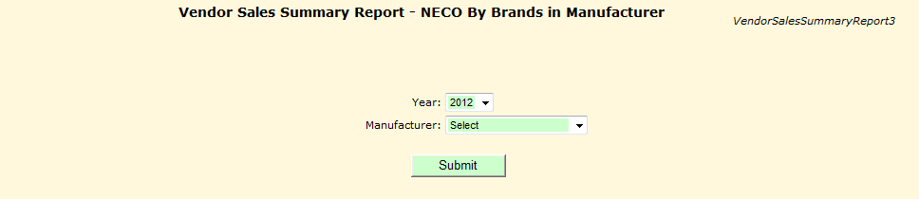

- from drop down list.
- to create the selected report in a new window, sample below.
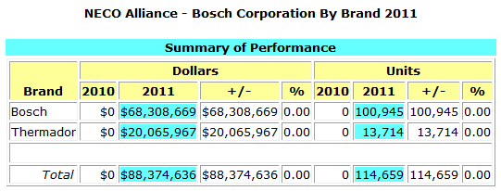

Vendor Sales Summary Report - Chapter By Manufacturer [VendorSalesSummaryReport4]

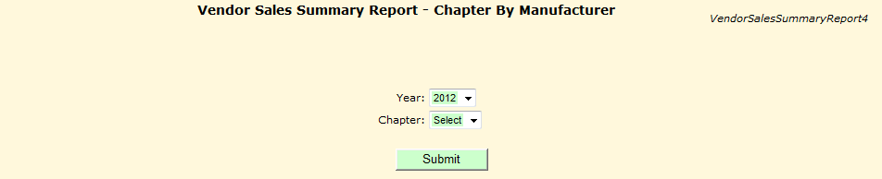

- from drop down list.
- from drop down list.
- to create the selected report in a new window, sample below.
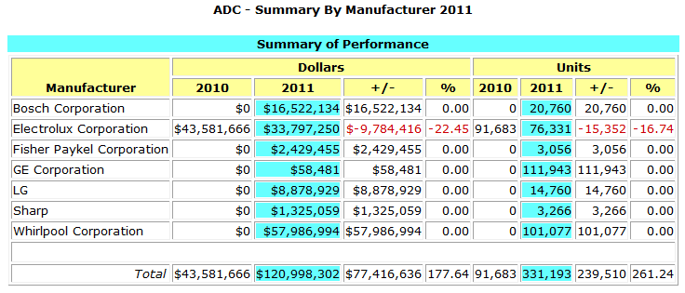

Vendor Sales Summary Report - Chapter by Brands in Manufacturer [VendorSalesSummaryReport5]

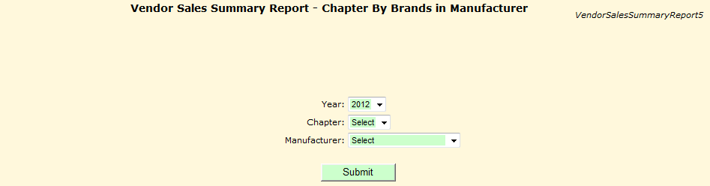

- from drop down list.
- from drop down list.
- from drop down list.
- to create the selected report in a new window, sample below.
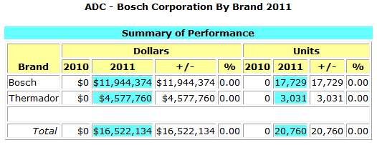

Documentation

Documentation [Documentation2]

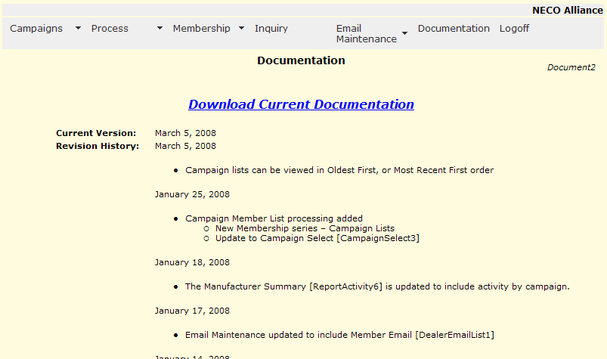

Displays the revisions for Chapter Processing.

- click to download Chapter Documentation.

Logoff

Logoff will log the user off the system and allow for another (or the same user) to logon.

