NECO Alliance

Rebate Processing

System

Manufacturer Processing

http://rebates.necoalliance.com/Login.php

Personal Systems Technology
www.PersonalSystems.biz
914-874-5184
Revision History

February 8, 2012
- NECO Merchandising Portal added [only available to authorized personnel]
May 9, 2011
- Model Summary report by invoice date by campaign added
December 3, 2009
- Campaign Discussion added [CampaignDiscuss1,2,4]
October 14, 2009
- Corporate login, campaign and email information
- Campaign Merchandising report [MerchReport1a]
January 16, 2007
- Campaign Select [CampaignSelect6] updated.
- Campaign Cycle Billing [VendorCycle1] added
December 23, 2007
- Initial distribution

Table of Contents

Overview 5
Summary 5
Life of a Campaign 5
Manufacturer Data Validation Functions 6
Product Serial Number Validation 6
Multiple Product Purchase Validation 7
Multiple Consumer Purchase Validation 7
Manufacturer / Corporate login and information 7
NECO Merchandising Portal 7
Rebate Creation 8
Amount with each model 10
Rebate Form 10
Package with Bonus 11
Rebate Form 11
Some Models Paired 13
Rebate Form 13
Specific Package with Bonus Models 14
Rebate Form 14
Variable Package 16
Rebate Form 16
Detail Processing 18
Login Processing 18
Menu 19
Campaigns 20
Campaigns [CampaignSelect6] 20
Example of “sample manufacturer” rebate form 21
Campaign Cycle Billing [VendorCycle1] 22
Report 23
Manufacturer Merchandiser Campaign Report [MerchReport1a] 23
Manufacturer Merchandiser Campaign Report [MerchReport1a] 25
Manufacturer Merchandiser Spreadsheet [MerchReport2] 27
Model Summary Report [ModelSumReport7] 28
Campaign Discussion – Overview 31
Campaign Review Discussion [CampaignDiscuss1] 32
Campaign Discussion – Facsimile [CampaignDiscuss2] 34
Campaign Discussion – individual [CampaignDiscuss4] 36
Cycle Billing [VendorCycle3] 37
Email Maintenance 38
Manufacturer Email Maintenance [ManufacEmail1] 38
Manufacturer Email Maintenance [ManufacEmail3] 40
Manufacturer Email Maintenance [ManufacEmail4] 41
Portal 42
Vendor Sales In Reports 43
Vendor Reports Sales Report By Manufacturer [VendorSalesReport1] 44
Vendor Sales Summary Report | NECO by Brands in Manufacturer [VendorSalesSummaryReport3] 46
Vendor Sales Summary Report - Chapter by Brands in Manufacturer [VendorSalesSummaryReport5] 47
Manufacturer Sales Data Entry [VendorSalesIn1] 48
Vendor Reports Sales In | Data Entry [VendorSalesIn3] 49
Documentation [Document4] 50

C
CampaignDiscuss1, 32
CampaignDiscuss2, 34
CampaignDiscuss4, 36
CampaignSelect6, 20
D
Document4, 50
M
ManufacEmail1, 38
ManufacEmail3, 40
ManufacEmail4, 41
ManufacEmail6, 38
ManufacEmail8, 40
MerchReport1a, 23, 25
MerchReport2, 27
ModelSumReport7, 28
V
VendorCycle1, 22
VendorCycle3, 37
VendorSalesIn1, 48
VendorSalesIn3, 49
VendorSalesReport1, 44
VendorSalesReport2, 45
VendorSalesSummaryReport3, 46
VendorSalesSummaryReport5, 47

Overview
The NECO Rebate web site consists of two major functional areas:
- The NECO Rebate System
- The NECO Merchandising Portal [this function is only available to authorized manufacturer personnel]

Both functions are described below:

Summary
The NECO Rebate Processing System intended to meet the needs of:
- Consumers – by providing easy to complete rebate forms, access to online status information, and payments consistent with NECO’s objectives.
- Chapter Members – by providing consistent rebate forms, available on demand, the ability to track consumer rebates and issues on line, the ability to log information regarding a specific consumer rebate, and online and downloadable reports.
- Chapters – by providing the ability to easily review and track campaigns from design through end-of-life, online and downloadable reports of rebate information by campaign or by date range.
- Manufacturers – by providing the ability to review and approve campaigns online and to have access to online or downloadable reports. Additionally, the NECO Rebate System provides several key data security validation checks to insure that only valid rebates are paid. Key data validation checks include: product serial number validation, multiple product purchase, and multiple consumer purchases.
- NECO headquarters – by providing an easy to design and manage rebate program which focuses on the efficiency of data entry to minimize labor cost and time.

Life of a Campaign
A campaign moves through four stages:
- Design – the Chapter Merchandisers, NECO Headquarters, and the manfuacturer agree on product, objectives, and structure of the campaign. A preliminary rebate form is created. Various rebate types (i.e. an amount paid by each model purchased, an amount based on the number of models purchased, pairs of models [washer/dryer], etc) are handled, as well as the formatting of the rebate form (i.e. one or two pages, explanatory information in header or footer areas, spacing, etc) and chapter/vendor billing information are all captured during the rebate “design” process.
- Preview – the Chapters (and Retail Deck) and the manufacturer are notified via email that a rebate form is available on the NECO website for review and approval. Chapters and the manufacturer are responsible for timely signoff to insure that the campaign can become active on the targeted date.
- Active – Chapters (and Retail Deck), Chapter Members, and the manufacturer are notified via email that a campaign is now available for consumer use. Rebate forms are posted on the NECO site. Consumer purchases of rebate product will occur with consumers completing and submitting necessary supporting documentation. NECO Headquarters will receive consumer completed rebates and enter them determining which rebates are valid and are to be paid, which rebates are classified as “pending” and require additional information from the consumer or which rebates are “rejected” because the rebate submission did not meet the qualifications of the rebate program. Consumers are notified via email (if they have provided an email address) or via post card if there are any issues. Consumers who have supplied an email address will receive a confirming email indicating the rebate has been received, the status of the rebate, along with a website address and tracking number which the consumer can determine the status of their rebate.
NECO Headquarters will collect campaign rebates and periodically (approximately every two weeks) will invoice the manufacturer and Chapters for any funds due. Manufacturers and Chapters can download spreadsheets that coincide with the invoiced information.
When NECO Headquarters has received funds for campaigns activities, Solutran (a check printing service provider) will be instructed to issue checks for valid rebate submissions. Solutran will supply back to NECO Headquarters information of paid checks. Consumers, chapters and chapter members will be able to view check numbers and paid information
- Closed – the campaign end date has been reached and no further purchases of vendor product are allowed after this date.

Manufacturer Data Validation Functions

Product Serial Number Validation
The NECO Rebate System allows for the validation of product serial numbers at data entry time. The system can validate serial numbers based on the following characteristics:

- A defined number of characters present in the serial number.
- Within the serial number each position may be defined as:
  - Any character may be present.
  - Only numeric character may be present
  - Only alphabetic character may be present
  - A specific character must be present (i.e. “C” or “1”)
- No validation

Multiple Product Purchase Validation
The NECO Rebate System automatically validates that the same product / serial number may not be claimed more than once.

Multiple Consumer Purchase Validation
The NECO Rebate System automatically validates that the same consumer is not claiming the same model for purchase on multiple rebate submissions.

Manufacturer / Corporate login and information
The user id and password that you use the access the rebate system is assigned by the NECO office. In cases where there are multiple “brands” associated with a corporate entity, you will be given ids and passwords associated with each brand that different individuals in your organization can use to access and review information relevant to that particular brand. You may be granted additional ids and passwords which provide access to view all of your brands and generate consolidated reports.

NECO Merchandising Portal
The NECO Merchandising Portal provides a communications, planning, and business measurement role for the NECO Merchandiser, Chapter Merchandisers, Chapter President’s and Manufacturers.

The portal initially provides manufacturer sales-in reporting data. The data is entered by the Manufacturers and is then viewable by summarized and detail information by manufacturer, brand, and chapter – with comparative data to previous periods.

In the future, the portal will be enhanced to incorporate sales event planning information and competitive activity.

Rebate Creation

The correct creation of a new rebate campaign is critical to the success of the Rebate Processing System. The Rebate System’s success is based on the creation of a new rebate campaign not only in creating the rules and qualification characteristics for a rebate, but in dynamically building the consumer rebate form as it is needed, defining the dealers who will participate in the campaign, providing communications to chapters, dealers, vendors and consumers, creating invoice information, issuing check writing instructions and handling consumer inquiries.

This tight integration of the campaign creation, the rebate form, and the rules and qualification criteria provides for central management of a rebate campaign. The rebate form is critical to a campaign, and the visual inspection of the rebate form identifies many of the criteria of the campaign.

The rebate form is actually constructed from a series of “building blocks”:

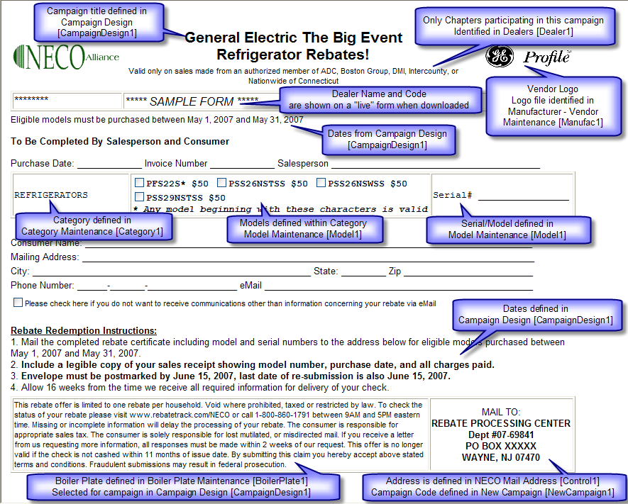

By using this “building block” approach, the Rebate System is capable of building and displaying a wide range of rebate qualification rules and implementing them in a consistent, easy to use, data entry, invoicing, check writing and consumer inquiry way.

The following rebate qualification rules are implemented within the system:

- Amount with each model – a rebate amount is identified for each model
- Package – a rebate amount is paid based on the number of models purchased
- Package with Bonus – a rebate amount is paid based on the number of models purchased and a bonus rebate is also paid if a minimum of a specified number of models is purchased
- Some models paired – in addition to a rebate being identified for some models, other models may be grouped as a “pair” with the qualification rule that the consumer must purchase one model from each of the groups within the pair. For example, a washer and dryer pair.
- Specific package with Bonus Models – qualification rules are established for models within various categories must be purchased in specific and/or combinations. For example, a purchase of a range or a refrigerator and a dishwasher. In this rebate offer, it is possible to define the rebate amount as determined by the consumer purchasing another category. For example, if the consumer purchases a range or a refrigerator and a dishwasher the rebate amount is determined by the purchase price of a cooktop purchased at the same time.
- Variable package – qualifications rules require that the consumer purchase a model from each category in the campaign (a category may consist of individual models, a pair, or consist of sub-categories). The rebate reward in a variable package is based on the purchase price of a model in a designated category, and the rebate reward price can have a maximum amount associate with it.

In addition the following can be defined in any rebate campaign:
- a maximum total rebate amount to be paid
- a minimum purchase price for a specific model, or pair, or package
The following rebate descriptions can be used independently as reference, or if read in order, as a tutorial of the various capabilities and definitions within the rebate system.

Amount with each model
The amount with each model has been the most commonly used rebate program. This program has a specific rebate amount associated with each model in a category.

Rebate Form
Note the use of the * at the end of a model number, will cause the italics comment at the end of the models listed for the category * Any model beginning with these characters is valid

Also note that in the model/serial section of the rebate form there is no space shown for the consumer to write-in the model number – checking the model in the model description area is sufficient. Also, only one serial # entry is provided.

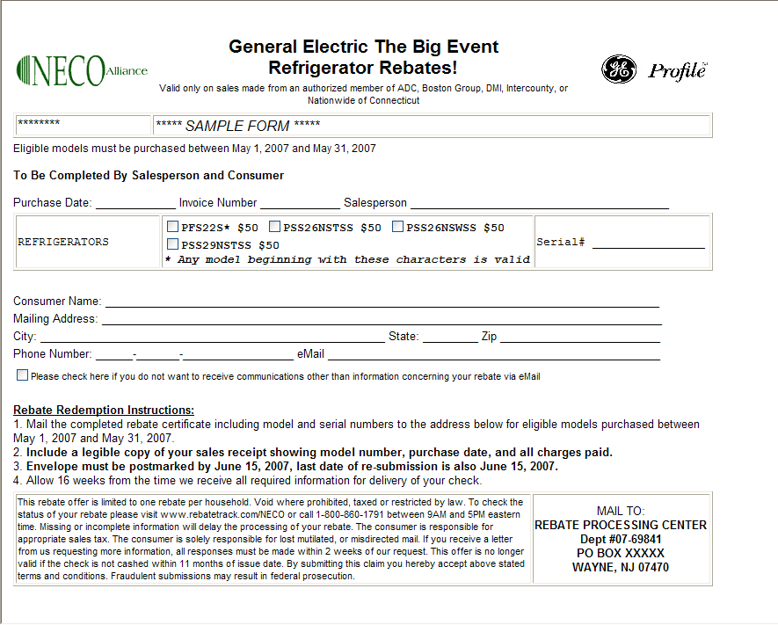

Package with Bonus

Rebate Form

Points to note:

- A “Header” is shown above the Category / Model / Model-Serial Number section, providing information to the consumer
- Model-Serial Number information is not shown for each category, but is shown at the bottom of the Category / Model section – this conserves space on the form to allow it fit on one page
- Additional information is shown below the models in the Built-in Refrigeration category.
- No rebate amounts appear next to the models, because this is a Package campaign.
- Line Spacing has been set to 0 to remove extra lines between Purchase Date / Invoice Number / Salesperson section and the Category / Model section, and between the Category / Model section and the Consumer information, and between the Consumer Information and the Rebate Redemption Instructions, and between the Rebate Redemption Instructions and the Boiler Plate.

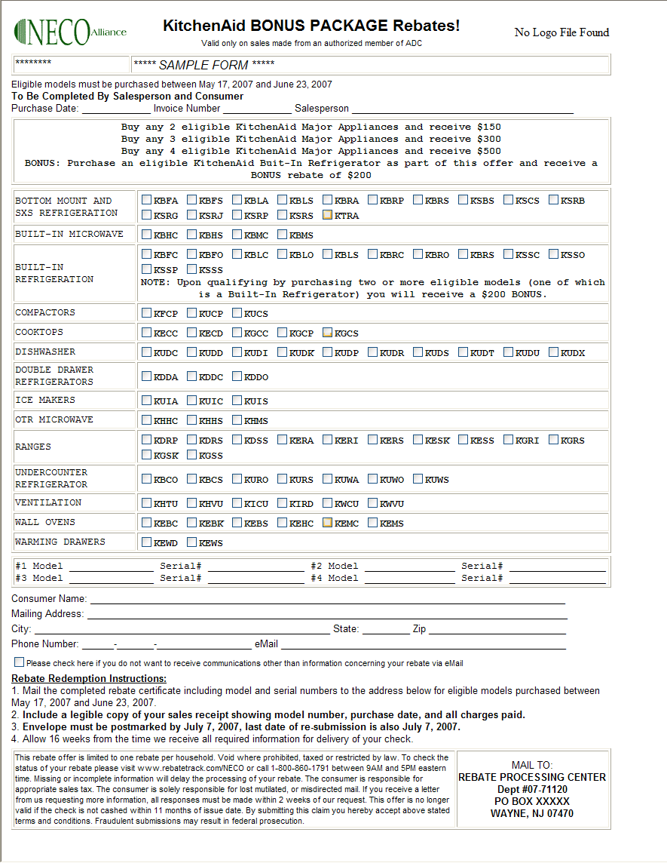

Some Models Paired

Rebate Form

Points to note:
- Laundry Pair of Washer/Dryer category, requires the consumer to purchase a washer and a dryer to qualify for the rebate.
- Two sets of Model/Serial information to entered by the consumer of the Laundry Pair
- Extra spacing between rebate form sections to improve the formatting of the rebate form on one page.

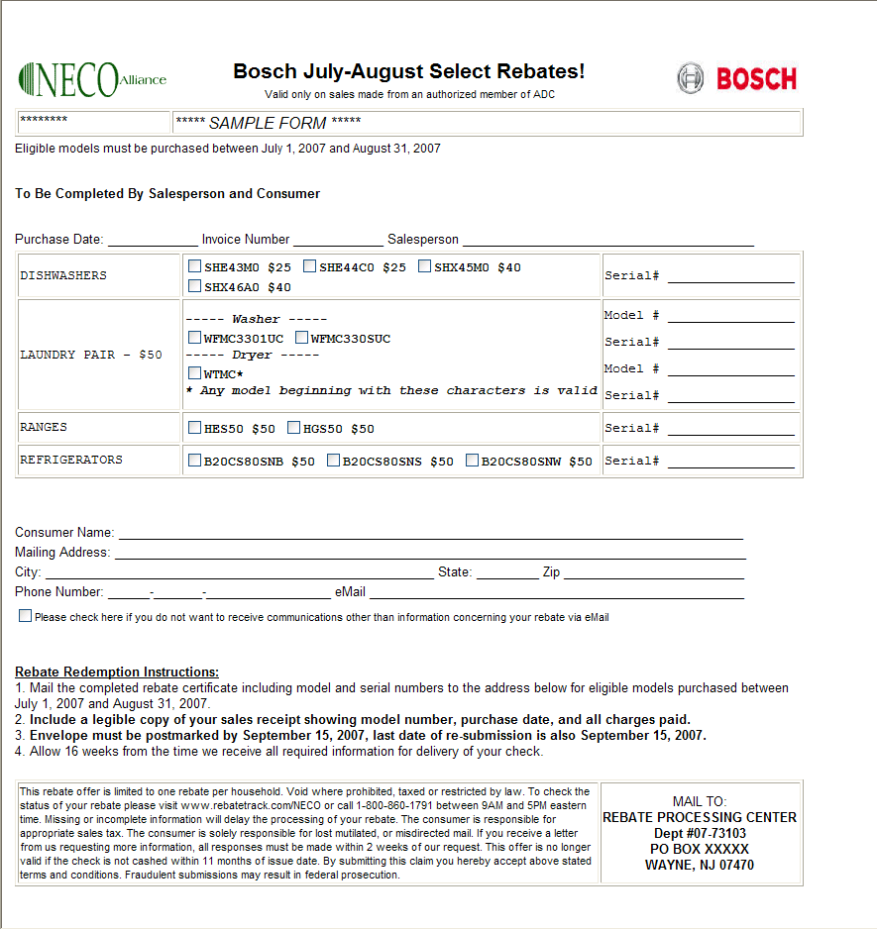

Specific Package with Bonus Models

A Specific Package is a rebate campaign where the consumer must purchase a model from a specific category (the qualification criteria can be established to require the consumer to require multiple categories of product).

Rebate Form

Points to note:
- Header and Footer information which appears above and below the category/ model/serial information to explain the campaign
- The category TV appears before the Home Theatre System category. Normally categories are listed in alphabetical order, however this rebate form shows TV first – this is done to make the rebate form more understandable by having the required (specific) category before the “bonus” category (which will only be paid when a qualifying TV model is purchased)
- Additional explanation under the models in the TV category to explain the campaign.

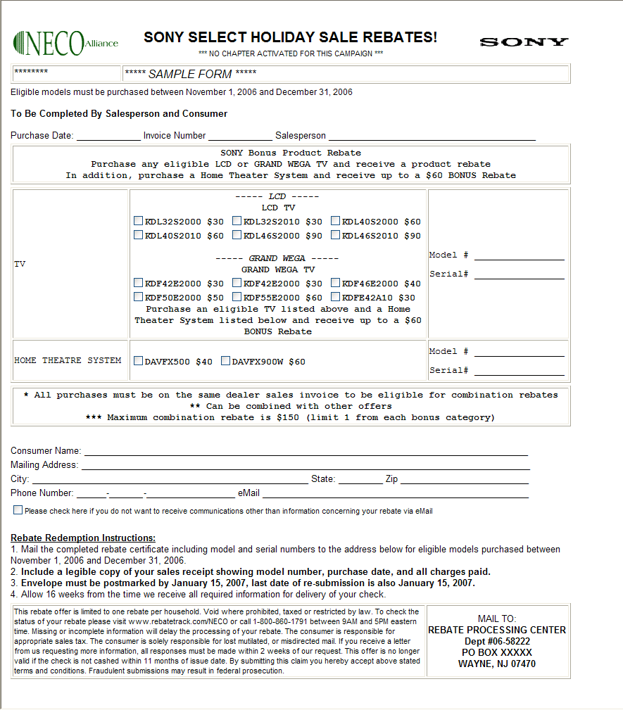

Variable Package
A Variable Package requires that the consumer purchase a model from each category (a category may be a pair or consist of sub-categories). The rebate reward in a variable package is based on the purchase price of a model in a designated category, and the rebate reward price can have a maximum amount associate with it.

Rebate Form
Points to note:
- The form spans two pages, and has the category / model information on the second page.
- The category / model information is shown in “compressed” format to save space
- Header text is used to explain the campaign
- Page footer/heading showing campaign name and page number

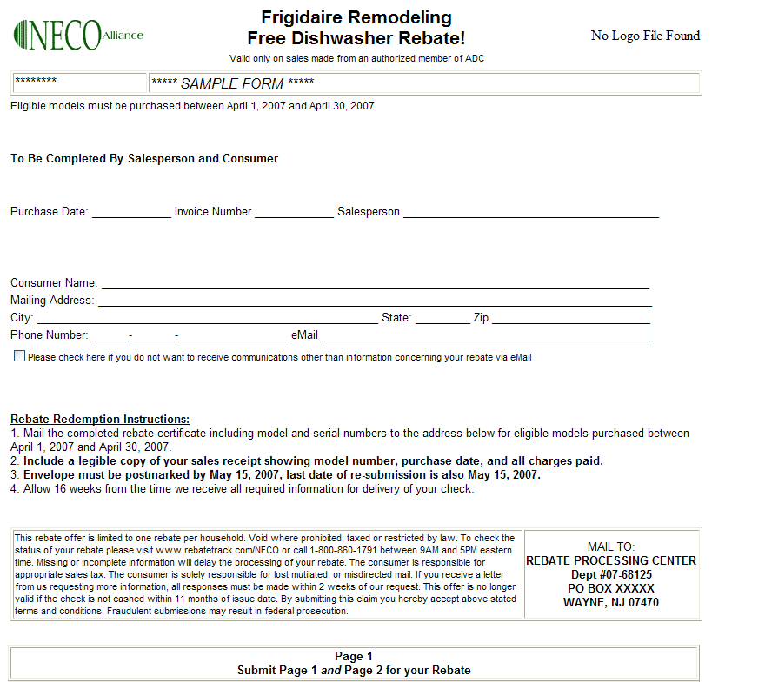

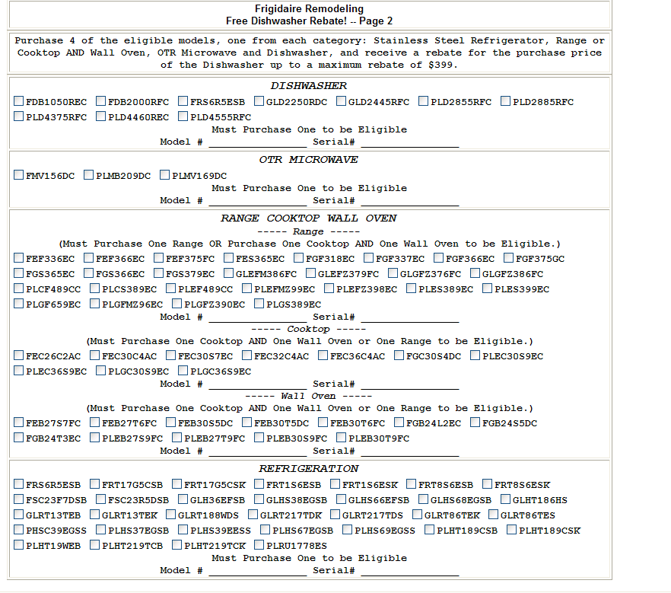

Detail Processing

Login Processing

Login to the Rebate Processing system at

http://rebates.necoalliance.com/Login.php

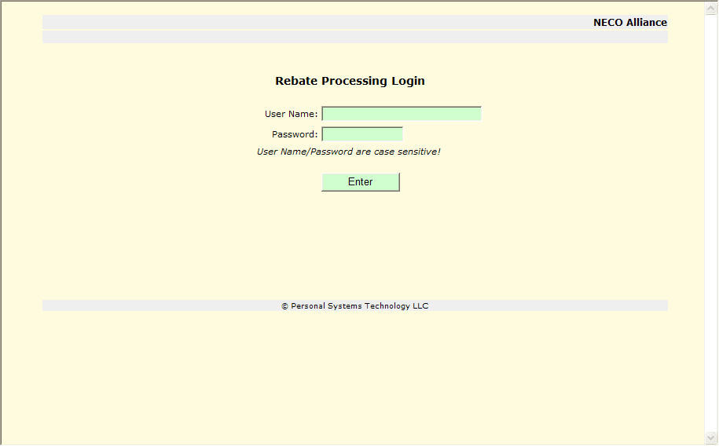

User login. User Name and Password are case sensitive.

The User Password must be 8-14 characters with a least one lower case letter, one upper case letter and one of the following special characters: !@#*+= If a User enters an incorrect password three times on the same day, the system will automatically suspend user rights and instruct the user to contact a Rebate System Administrator to have their password reset. The system will automatically require a new password to be created when a system determined time has elapsed.

Menu

The “Main Menu” will appear on each screen after proper login.

The user can select from the menu what key activity to use:
- Campaign – view campaigns for manufacturer, display rebate forms and download spreadsheet of campaign activity.
- Report – provides the downloaded spreadsheet, or on screen report of rebate/warranty activity for a specified period of time for the selected campaigns
- Discussion – allows for the online discussion of changes to campaigns
- Billing Cycle – download spreadsheet of billing activity by billing cycle.
- Email Maintenance – add / update / delete email addresses of Manufacturer personnel who should receive email notification of new or changed rebates.
- Portal – provides for manufacturer entry and review of information for NECO merchandisers.
- Documentation – shows the revision history for documentation, and the ability to download Manufacturer documentation for the Rebate System.
- Logoff – logs user off of the Rebate System.

Campaigns

Campaigns [CampaignSelect6]
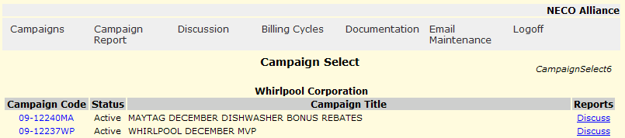

All Rebate Campaigns in Preview, Design, Active of Closed state are listed in chronological sequence. If there are more than 15 campaigns then VCR like controls will be present to allow for the scrolling of all campaigns.

Process provides access to information regarding Rebate Campaigns, information of rebate activity by date range, and downloadable spreadsheets of rebate activity that coincides with NECO invoices for Rebate activity.

- 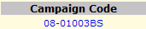 Select the campaign code to display a “manufacturer’s copy” of the Rebate Form in a secondary window.
- Select “Cycle Billing” and control will transfer to Campaign Cycle Billing [VendorCycle1] to review cycle billing information and spreadsheet download.
Select “Discuss” to transfer to Campaign Discussion [CampaignDiscuss1] for an online discussion of campaign changes.

Example of “sample manufacturer” rebate form:

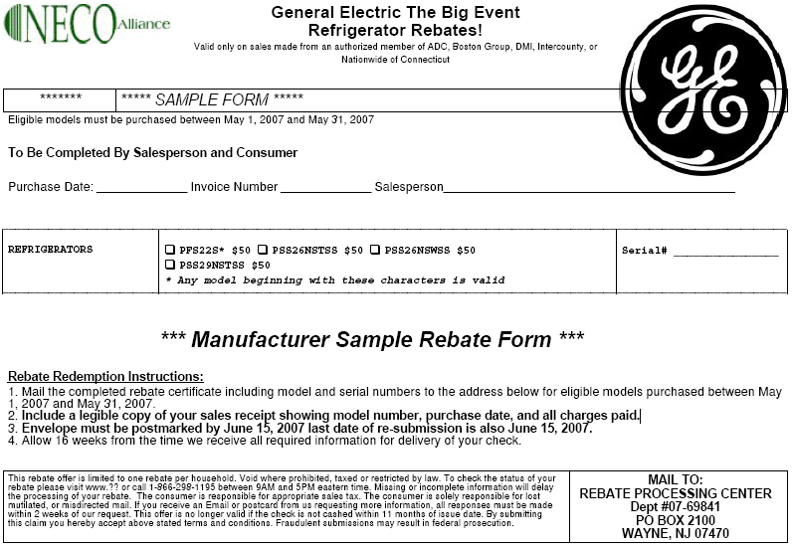

For security reasons, the “Manufacturer Sample Rebate Form” is specifically marked, and it does not contain space for consumer related information.

Campaign Cycle Billing [VendorCycle1]

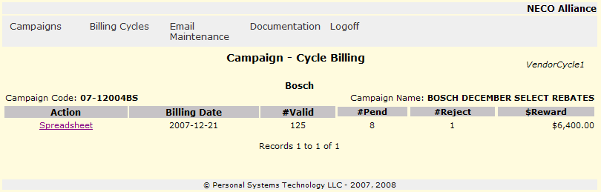

Campaign Cycle Billing displays all billing activity for a campaign.

A summary of the campaign cycle billing is shown with the number of rebates categorized as Valid, Pend and Reject along with the total reward dollars. Up to fifteen billing cycles are displayed, if there are more, than VCR like buttons will be present to advance through the entire list.

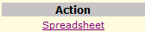 Select this action to download a spreadsheet with detailed information of about this campaign in the billing cycle.

Report

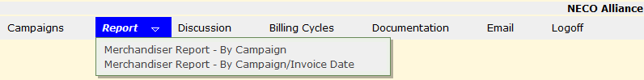

Create either an on-screen or spreadsheet report of model activity within campaigns, or for a specific invoice period with campaigns

Manufacturer Merchandiser Campaign Report [MerchReport1a]

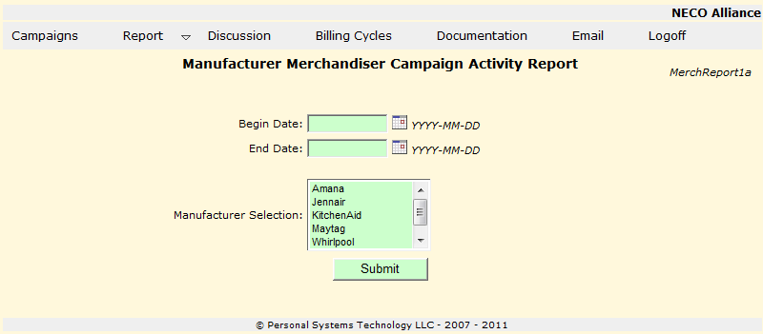

Generate Merchandiser Campaign Activity spreadsheet report.

- either enter the report start date or use the calendar picker to identify the beginning start date of campaigns to be included in this report
- either enter the report end date or use the calendar picker to identify the ending date (the campaign start date) to be included in this report
- 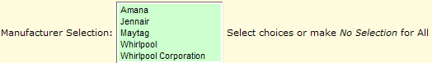 Select which manufacturers you wish to appear on the Merchandiser Spreadsheet. Use the <control key> to select non-adjacent manufacturers, use the <shift key> to select adjacent manufacturers. If no manufacturers are selected, all will be contained in the report.
- transfer control to MerchReport2 to identify any campaigns to not include in this report

Manufacturer Merchandiser Campaign Report [MerchReport1a]

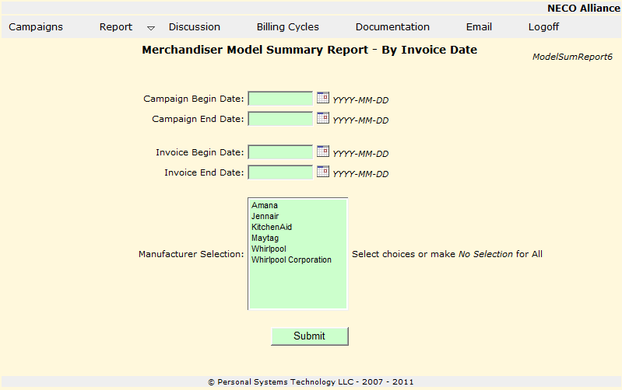

Generate Merchandiser Model Summary Report by Invoice Date spreadsheet report or on-screen report

- either enter the report start date or use the calendar picker to identify the beginning start date of campaigns to be included in this report
- either enter the report end date or use the calendar picker to identify the ending date (the campaign start date) to be included in this report
- either enter the invoice begin date or use the calendar picker to identify the beginning invoice date to be included in this report
- either enter the invoice end date or use the calendar picker to identify the ending invoice date to be included in this report
- Select which manufacturers you wish to appear on the Merchandiser Spreadsheet. Use the <control key> to select non-adjacent manufacturers, use the <shift key> to select adjacent manufacturers. If no manufacturers are selected, all will be contained in the report.
- transfer control to ModelSumReport7 to identify any campaigns to not include in this report

Manufacturer Merchandiser Spreadsheet [MerchReport2]
Remove campaigns

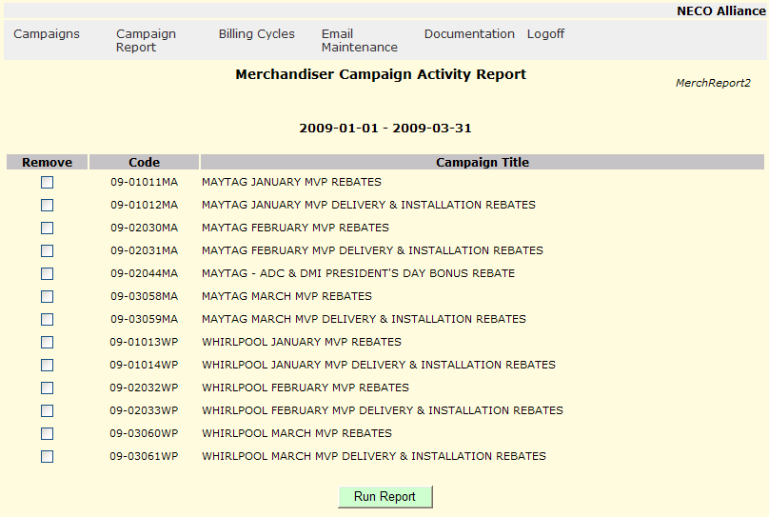

Identify which campaigns to not include the spreadsheet.

- 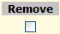click each campaign which you wish to not appear on the spreadsheet
- 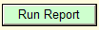 to generate your spreadsheet – MerchReport2 will remain displayed to allow to modify the campaigns to be included in the spreadsheet and re-run

Model Summary Report [ModelSumReport7]

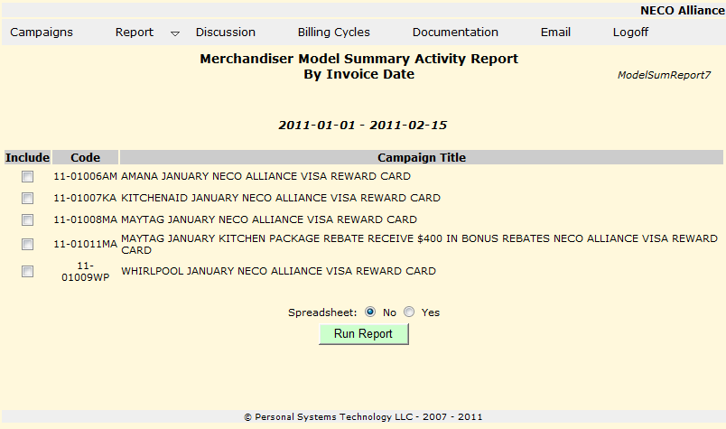

- Select campaigns to be included in report.
- Select either a spreadsheet or on-screen report and . Control will transfer and report will be created

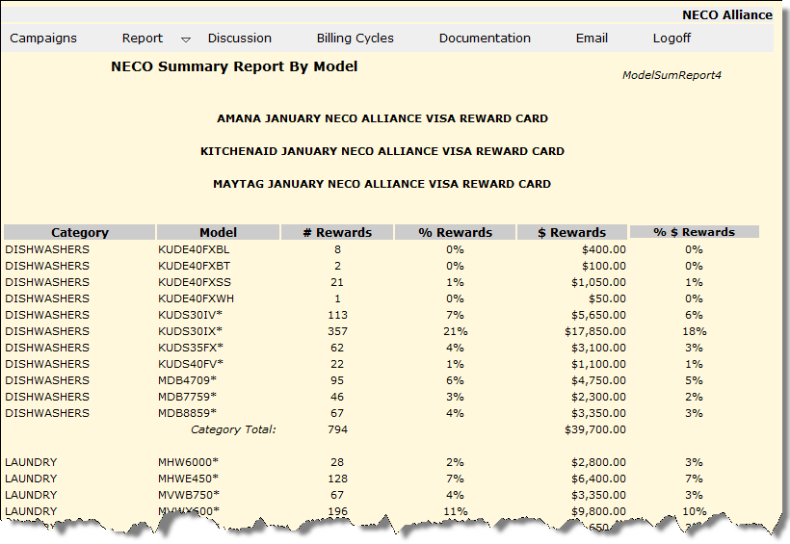

Campaign Discussion – Overview

Campaign Discussion provides for easy communication and review of rebate campaigns. It provides for communication between the rebate system administrator, NECO merchandising coordinator, Chapter merchandisers and Manufacturers.

If there are comments for any campaign which you have not viewed, a “campaign discussion” reminder will appear on the top banner of all screens in the rebate system.

The main entry to the Campaign Discussion is through the Campaign Review Discussion screen [CampaignDiscuss1] which is selected from the “Discussion” selection on the system menu (the NECO merchandising coordinator, and the NECO chapter merchandisers access this under “Campaigns” on the main menu, Manufacturers access “Discussion” directly from the main menu).

Also, campaigns which have comments associated with them which you have not reviewed will be highlighted in your Campaign Select list (from the menu selection).

You can create comments for a campaign which is currently not part of the Campaign Discussion by going to Campaign Select and selecting the “Discuss” selection on that campaign entry.

Campaign Review Discussion [CampaignDiscuss1]

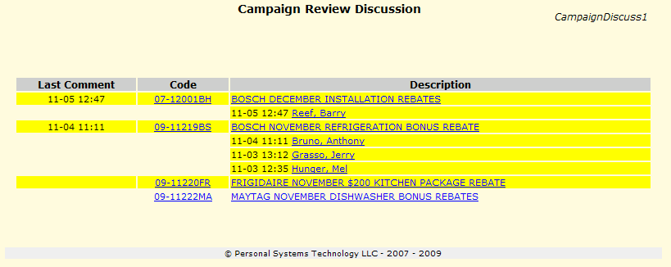

Campaigns are listed in campaign code order sequence (oldest campaigns first). If there are comments (or a campaign has been posted in Preview) that you have not yet reviewed, the campaign is highlighted in yellow. If there are comments posted regarding a campaign, the date/time stamp of the most recent comment is listed under “Last Comment”. Each individual who has made a comment to a campaign is listed in alphabetical order with the date/time stamp of their most recent comment.

Actions:
- 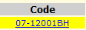 (campaign code used for illustration only) selecting the campaign code will display [CampaignDiscuss2] a facsimile of the rebate form, all comments in chronological order (most recent first) and allow you to add your comment for others to see. Selecting this choice will remove your highlighting of this campaign the next time you return to this screen. The campaign will be highlighted the next time that you view this screen if another individual has added a comment.
- (campaign name used for illustration only) selecting the campaign name will open a new window and display a sample of the actual rebate form for this campaign.
- (individual name, date/time stamp for illustration only) selecting an individual who has made a comment will display Campaign Discussion – individual [CampaignDiscuss4] which will show only comments made by this individual regarding this campaign in chronological order with the most recent comment first. You can add your own comment which all other reviewers will be able to see and this campaign will be highlighted on the other reviewers screens to indicate that a change has occurred.

Campaign Discussion – Facsimile [CampaignDiscuss2]

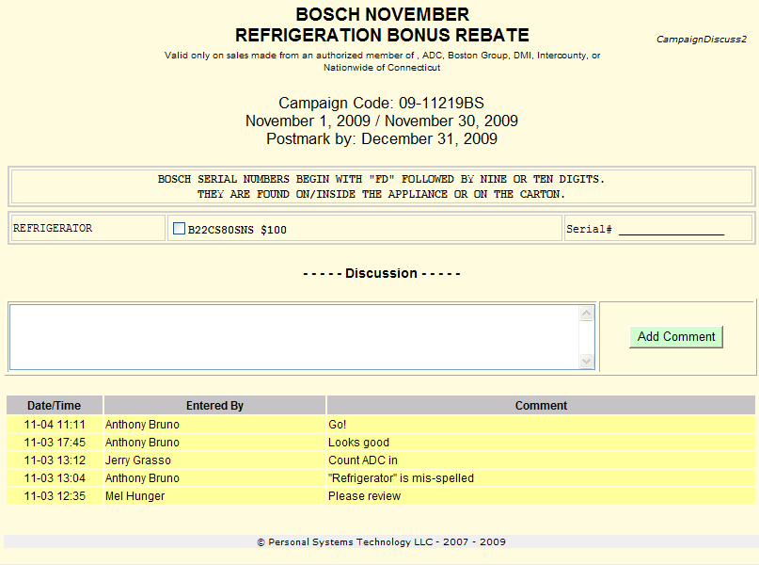
Shows a facsimile of the rebate form (all pertinent information is displayed, but the formatting may be slightly different). The top of the screen displays:
- Campaign name
- Chapters which have been activated to participate in the campaign
- Campaign code
- The date range when the campaign is active.
- The postmark date by which all submissions must reach the NECO Rebate office.
- “Header” information may be present to provide a further description of the campaign
- The models grouped within categories for the campaign with any additional information which may be pertinent to this campaign.
- “Trailer” information may be present to provide further description of the campaign

Following the facsimile of the rebate form is the “Discussion” area. It is here that you can add comments which all other reviewers will see. A comment can be up to 1000 characters and you must select “Add Comment” after you complete your comment entry for it to be visible to others. Adding a comment will cause this campaign to be highlighted on all other reviewers screens when they review campaigns. When you select “Add Comment” this screen will be re-displayed and you will see your comment appended to the top of the “discussion” list.

Last, all previous comments for all individuals regarding this campaign will be displayed in chronological order, with the most recent comment first.

Campaign Discussion – individual [CampaignDiscuss4]

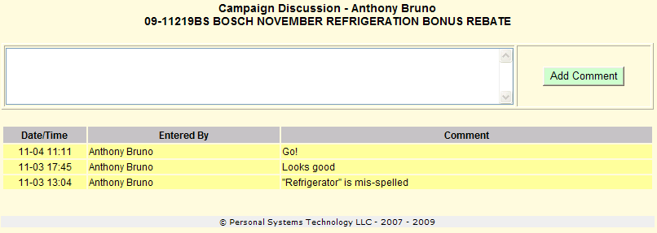

This screen shows all comments by the selected individual for this campaign in chronological sequence with the most recent first.

You can add your own comment (up to 1000 characters) and when you select “Add Comment” you will be transferred back to Campaign Discussion – Facsimile [CampaignDiscuss2] with your comment added. Also, all other reviewers will now see your comment and this campaign will be highlighted in their list of campaigns.

Billing Cycles

Cycle Billing [VendorCycle3]
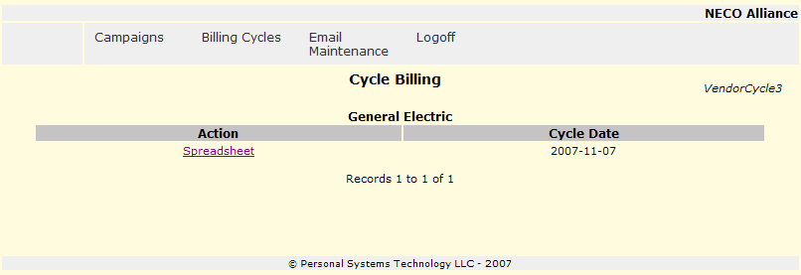

Display billing cycles in chronological order with the most recent first.

If there are more than 15 campaigns then VCR like controls will be present to allow for the scrolling of all campaigns.

- 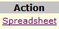 to download a spreadsheet of details of rebate activity for this cycle. The spreadsheet will contain information for all campaigns since the last billing period. Utilize this spreadsheet for review of the NECO invoice coinciding with this cycle.

Note: if you are logged on as the “corporate” id, an additional column will be present to identify the manufacturer for a particular spreadsheet.

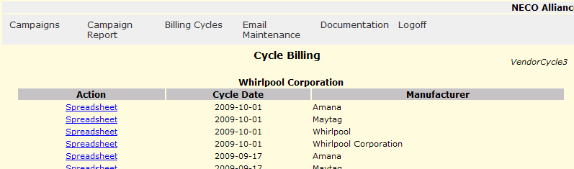

Email Maintenance

Additional Email addresses may be added / deleted / updated for Rebate System Notifications. The Rebate System communicates via email for Campaigns which are available for Preview, Campaigns which are entering an Active state and for other rebate campaign communications.

Manufacturer Email Maintenance [ManufacEmail1]

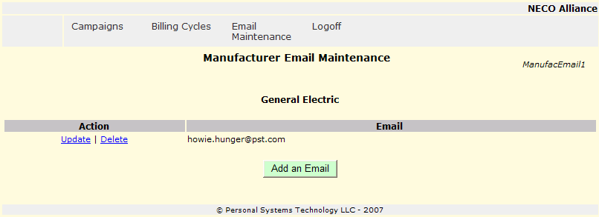

- 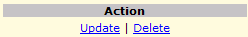 to Update or Delete the currently selected email address
  - Update will transfer to Manufacturer Email Maintenance [ManufacEmail3], if logged on with corporate id control will transfer to Manufacturer Email Maintenance [ManufacEmail8]
  - Delete will transfer to Manufacturer Email Maintenance [ManufacEmail4]
- to add a new email address and transfer to Manufacturer Email Maintenance [ManufacEmail3], if you are logged on with the corporate id control will transfer to Manufacturer Email Maintenance [ManufacEmail8]
If you are logged on with the corporate id then ManufacEmail6 will be displayed which included a Manufacturer column to associate an email address with the particular brand.

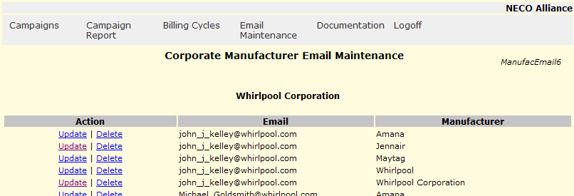

Manufacturer Email Maintenance [ManufacEmail3]

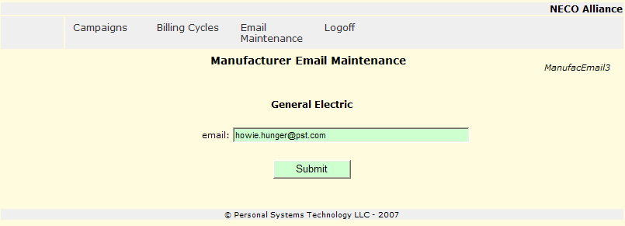

- enter (add/update) an email address
- to record updates and transfer control to Manufacturer Email Maintenance [ManufacEmail1]
Note: if logged on with the corporate id then ManufacEmail8 will be displayed which provides a pull down list to select the manufacturer to associate with this email address.

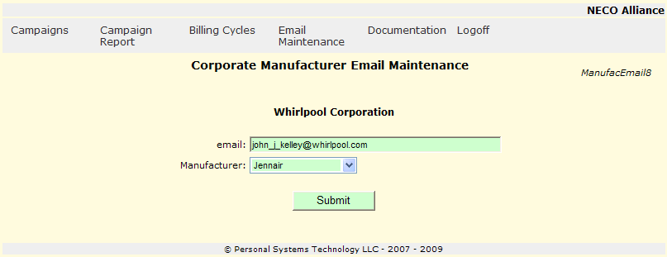

Manufacturer Email Maintenance [ManufacEmail4]

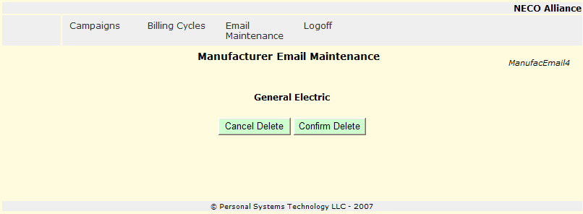

- to cancel to delete of the Email address and transfer control to Manufacturer Email Maintenance [ManufacEmail1]
- to delete the Email address and transfer control to Manufacturer Email Maintenance [ManufacEmail1]

Portal
Portal functions are only available to authorized manufacturer personnel.

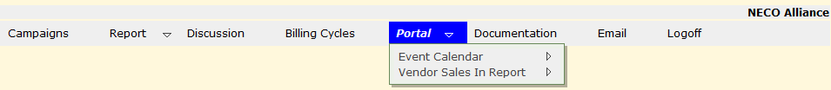

The NECO Merchandising Portal provides information for manufacturer merchandisers and NECO Merchandisers.

Key functions provided:
- Event Calendar – TBD
- Vendor Sales In Report
  - Various reports by manufacturer, brand, chapter of sales in activity
  - The manufacturer merchandiser has the ability to update, add sales in information

Vendor Sales In Reports

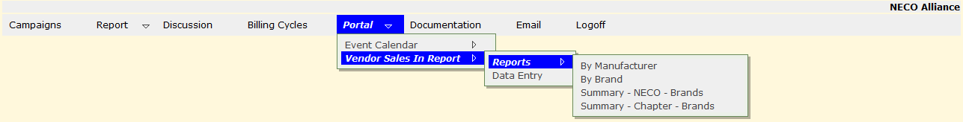

Vendor Sales In Reports provides multiple reports showing sales in activity.

By Manufacturer
- Displays a report for a selected manufacturer activity for NECO for a selected period.
- Control is transferred to VendorSalesReport1
By Brand
- Display a report for a selected brand activity for NECO for a selected period.
- Control is transferred to VendorSalesReport2
Summary – NECO – Brands
- Displays a report of brands for a selected manufacturer activity for NECO for a selected period.
- Control is transferred to VendorSalesSummaryReport3
Summary – Chapter – Brands
- Displays a report of brands within a manufacturer for a selected chapter for a selected period.
- Control is tranferred to VendorSalesSummaryReport5.

Vendor Reports Sales Report By Manufacturer [VendorSalesReport1]

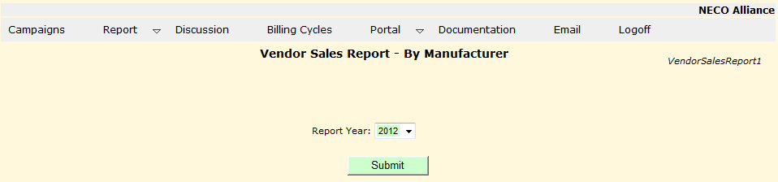

- from the drop down list.
- to create the selected report in a new window, sample below.

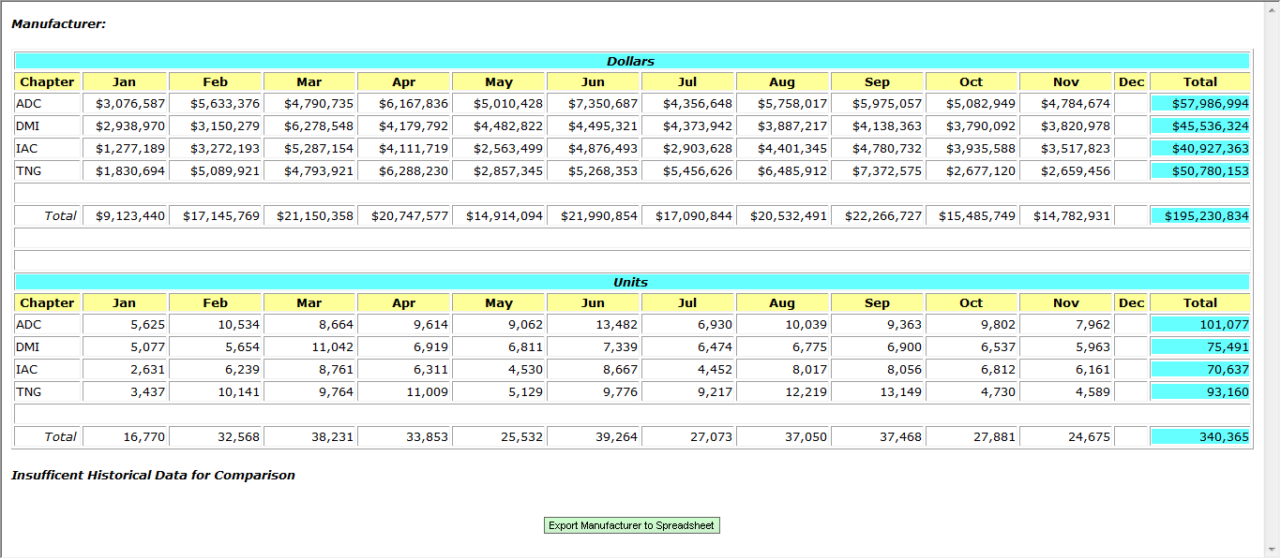

Select to download a spreadsheet showing total manufacturer activity and a separate tab for each brand.
Vendor Reports Reports By Brand [VendorSalesReport2]
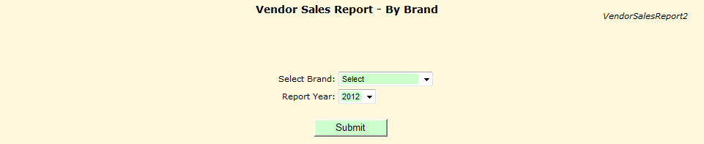

- from drop down list.
- from drop down list.
- 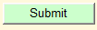 to create the selected report in a new window, sample below.
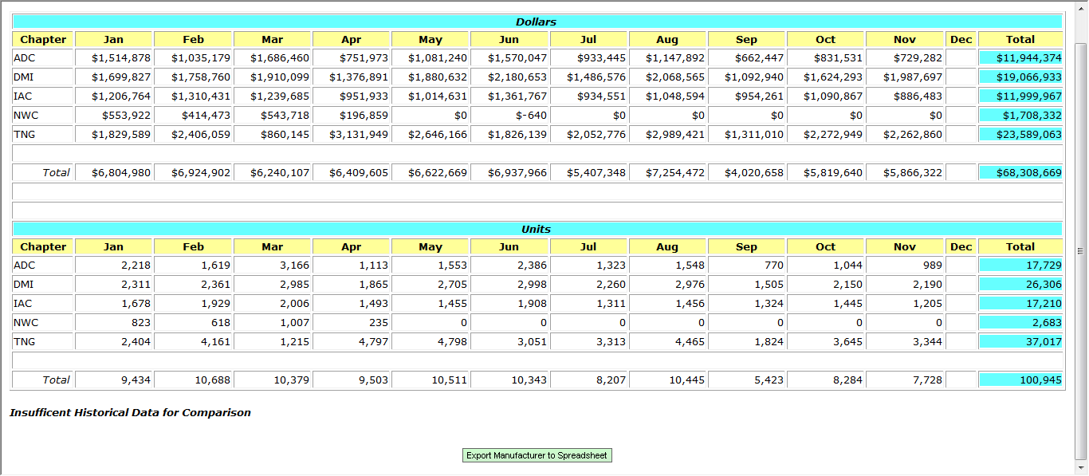

Select to download a spreadsheet showing total manufacturer activity and a separate tab for each brand.

Vendor Sales Summary Report | NECO by Brands in Manufacturer [VendorSalesSummaryReport3]

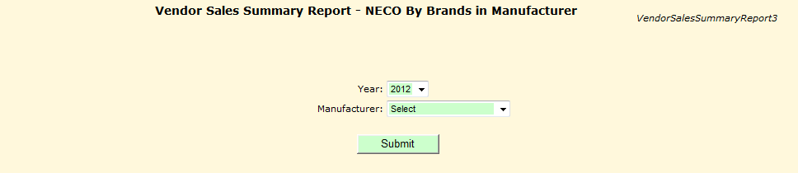

- from drop down list.
- to create the selected report in a new window, sample below.
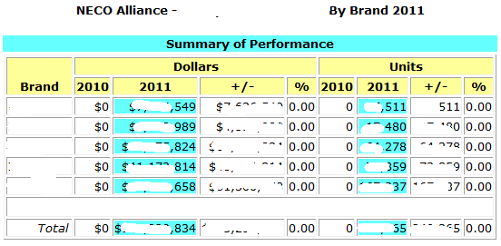

Vendor Sales Summary Report - Chapter by Brands in Manufacturer [VendorSalesSummaryReport5]

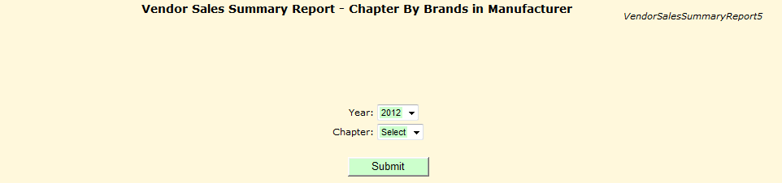

- from drop down list.
- from drop down list.
- to create the selected report in a new window, sample below.
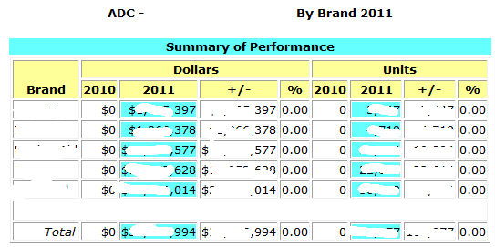

Manufacturer Sales Data Entry [VendorSalesIn1]

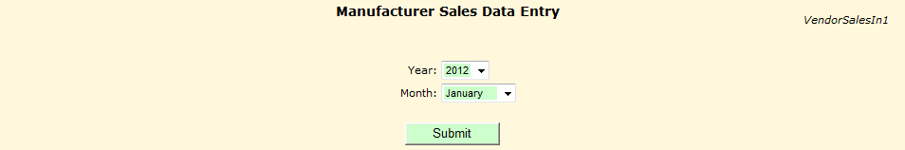

- from drop down list.
- from drop down list.
- and control with transfer to Manufacturer Sales Data Entry [VendorSalesIn3] for data entry.

Vendor Reports Sales In | Data Entry [VendorSalesIn3]

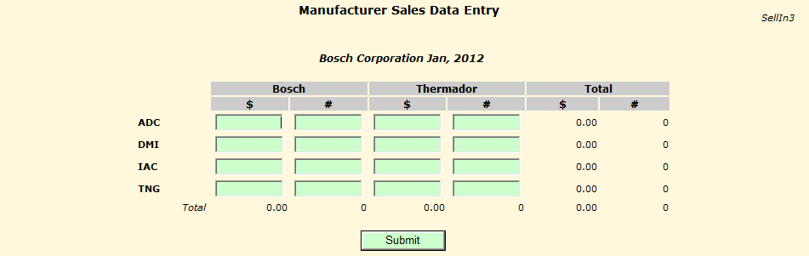

Enter $s and #s by chapter by brand.

When submit is selected the brand $/# columns and the chapter $/# rows will be totalled.

When data entry is correct and completed, select another menu item.

Documentation [Document4]

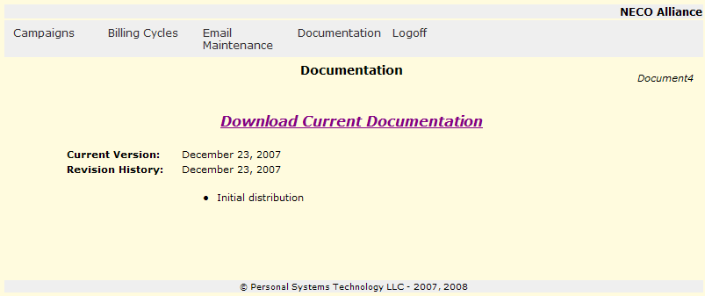

Shows a history of revisions to the Manufacturers documentation.

Select to download the most current documentation.
Logoff

Logoff will log the user off the system and allow for another (or the same user) to logon.



